

Training Pal

Final Year Project Report

DT228

BSc in Computer Science

**Daniel Tilley**

**Edina Hatunic-Webster**

School of Computing

Dublin Institute of Technology

**13th April 2018**



Abstract

The goal of this project is to create a tool that will assist both athletes and coaches in manging and sharing training data. Human interaction is also a key component of this project and is implemented through video calling / conferencing.

The system is accessible via web browser (fully) and through a mobile app (partially). Both athletes and coaches are able to utilise a simple, clean, yet functional user interface to complete a number of tasks. These include the creation of training log entries, searching for users, managing training targets, one to one video consultations and also graphical representation of data.



Acknowledgements

I would like to firstly thank my project supervisor Edina Hatunic-Webster for all her help and advice throughout the project process over the last few months. Secondly, I would like to thank all the lecturers, lab assistants and tutors who have assisted me during my time in DIT and who have also enabled me to complete my final year project. Finally, I would also like to thank my mum, dad and brother for all their support throughout the past four years. Special thanks also to my girlfriend and my friends who have also helped me along the way.

Table of Contents

**1.** **Introduction** 10

**Overview** 10

**Project Objectives** 10

**System Overview** 10

**Structure of the document** 11

**2.** **Background Research** 12

**Alternative Solutions** 13

Strava.com 13

TrainingPeaks.com 14

Runtastic.com 15

**Methodology and Approach** 16

Continuous Integration 16

Scrum Methodology 16

Iterative Design 17

Pomodoro Technique 17

Kanban Board 18

Gantt Chart 18

**Technologies Requirements** 19

Angular 19

React 19

Bootstrap 20

PHP 20

MySQL 20

Mongo DB 21

Apache HTTP 21

Nginx 22

Python 22

Java 23

Android 23

Angular-nvD3 24

Ng 2 Charts 24

SimpleWebRTC 24

Peer.js 25

AWS 25

Digital Ocean 26

Recommender Systems 26

Collaborative Filtering 27

Content Based Filtering 27

Artificial Neural Networks 28

K Nearest Neighbour 28

Travis CI 29

Selenium 29

**Findings** 30

Researched Technologies 30

Chosen Technologies 31

Other Findings 31

**Requirements Table** 32

Web Application 32

Mobile Application 33

**3.** **Design** 34

**Chosen methodology and approach** 34

Iterative Design 34

Kanban Board 34

Pomodoro Technique 36

Gantt Chart 36

Technical Architecture Diagrams 36

Entity-Relationship Diagrams 38

**Use Cases** 38

User 38

Coach 39

Athlete 40

**Angular App Prototype** 41

**Android App Prototype** 43

**4.** **Implementation & Development** 43

**Overview** 43

**Databases** 43

MySQL 43

**Servers** 44

Python API and MySQL 46

Angular App and Static Site 46

**Source Code Layout** 47

Angular App 47

Android Mobile App 48

**Python API** 50

**Angular App** 51

**Android Application** 52

**5.** **System Validation** 52

**Overview** 52

**Requirements Testing** 52

**Unit Testing** 53

**Black Box Testing** 54

**System Testing** 54

**Test Cases** 58

Web Application 58

Mobile Application 61

**6.** **Project Plan Evaluation** 61

**Original Estimated Effort** 61

Web Application 61

Mobile Application 62

**Changes Made to Requirements** 63

**PHP to Python** 63

**Servers** 64

**Results and Evaluation** 64

**7.** **Conclusion** 65

**Project Conclusion** 65

**Future Plans** 65

**8.** **Bibliography** 65

**9.** **Appendix** 69

**User Guide** 69

Training Pal Mobile App 69

Training Pal Web App 74

**Admin Guide** 84

Servers 84

Table of Figures

Figure 1: System Overview 10

Figure 2: Technical Architecture Diagram (Components) 11

Figure 3: Strava Dashboard 14

Figure 4: Training Peaks Dashboard 15

Figure 5: Runtastic Dashboard 16

Figure 6: Iterative Design Process 34

Figure 7: Kanban Board 35

Figure 8: Kanban Board Component Comment 35

Figure 9: Pomodoro Technique 36

Figure 10: Technical Architecture Diagram (Network) 37

Figure 11: Technical Architecture Diagram (Components) 37

Figure 12: Entity Relationship Diagram 38

Figure 13: User Use Case Diagram 39

Figure 14: Coach Use Case Diagram 39

Figure 15: Athlete Use Case Diagram 40

Figure 16: Angular Prototype Login Screen 41

Figure 17: Angular Prototype Profile Screen 42

Figure 18: Angular Prototype Sign Up / Edit Profile Screen 42

Figure 19: Android Prototype Login Page 43

Figure 20: Passwords Encrypted at Rest 44

Figure 21: Servers and Domain Name 45

Figure 22: Digital Ocean DNS Records 45

Figure 23: Https Certificate 45

Figure 24: TrainingPal API Base Url 46

Figure 25: DbManager Url 46

Figure 26: Training Pal Website Url 47

Figure 27: Training Pal Web App Url 47

Figure 28: Angular App Code Layout 48

Figure 29: Mobile App Code Layout 49

Figure 30: Rest API Code Layout 50

Figure 31: Postman Unit Test 53

Figure 32: Android Unit Test Cases 54

Figure 33: Usability Survey 56

Figure 34: Usability Survey Answer 1 56

Figure 35: Usability Survey Answer 2 57

Figure 36: Usability Survey Answer 3 57

Figure 37: Usability Survey Answer 4 57

Figure 38: Usability Survey Answer 5 58

Figure 39: Usability Survey Answer 6 58

Figure 40: Gantt Chart 63

Figure 41: Mobile App Login Screen 69

Figure 42: Mobile App Sign Up Screen 70

Figure 43: Mobile App Main Menu 70

Figure 44: Mobile App Daily Logs Screen 71

Figure 45: Mobile App Monthly Logs Screen 71

Figure 46: Mobile App Create Log Screen 72

Figure 47: Mobile App View log Screen 72

Figure 48: Mobile App Update Log Screen 73

Figure 49: Mobile App View Profile Screen 73

Figure 50: Mobile App Update User Screen 74

Figure 51: Web App Login Page 74

Figure 52: Web App Sign Up Page 75

Figure 53: Web App Athlete Navbar 75

Figure 54: Web App Coach Navbar 75

Figure 55: Web App Dashboard Page 76

Figure 56: Web App User Search Page 76

Figure 57: Web App Your Events Page 77

Figure 58: Web App Create New Event Dialog 77

Figure 59: Web App Event Page 78

Figure 60: Web App Profile Page 78

Figure 61: Web App Edit Profile Page 79

Figure 62: My Invites Page 79

Figure 63: Targets Page 80

Figure 64: Web App Create New Target Dialog 80

Figure 65: Web App Graph Page 80

Figure 66: Web App My Coaches Page 81

Figure 67: Web App Training Log Calendar Page 81

Figure 68: Web App Training Log List Page 81

Figure 69: Web App Training Log Create Page 82

Figure 70: Web App Training Log View Page 83

Figure 71: Web App Templates View Page 83

Figure 72: Web App Template View Page 84

Figure 73: ssh connection 84

Figure 74: Filezilla API Connection 85

Figure 75: Filezilla Web Server Connection 85

# **Introduction**

## **Overview**

Training Pal is intended to be the only companion an athlete needs when training. A web application allows users to access information about their training simply and efficiently to help them progress. A mobile application also allows for data entry no matter where the user is so that no piece of data goes un recorded.

The idea for Training Pal was conceived during a conversation with a triathlon coach. He told me about his struggles with current technologies in the market. Although many of them offered quite a lot of functionality, they were at times difficult to understand and use and sometimes lacked very basic pieces of functionality that were key to a coach’s arsenal. I spotted a gap in the market and decided to use the idea for my final year project.

## **Project Objectives**

The overall goal of this project is to create an easy to use and intuitive web application that will allow athletes and coaches to manage their training data. In addition to this, a standalone mobile app will sit alongside it to offer data entry functionality to end users. As it stands, the application focuses solely on triathlon (swimming, cycling and running). Once I finish my degree however, I intend to branch out into other sports.

Another aim of mine is to incorporate some form of human interaction into the application. When it comes to availing of services from an individual/group, it’s always nice to be able to put a face or a name to what we are being offered. Sometimes we can be no more than a number/username or a reference to either a computer or someone on the other end.

## **System Overview**

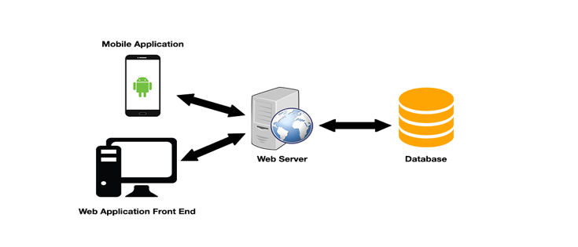

Figure 1: System Overview

The above image shows my proposed architectural approach for the project. It consists of a basic three tier model with the first tier separated into two separate components. A more in-depth breakdown can be seen in the image below.

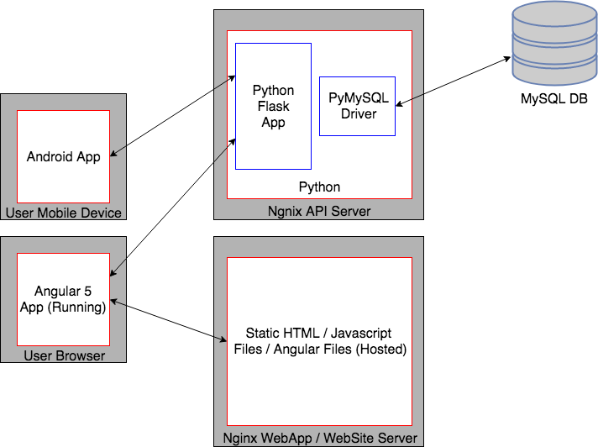

Figure 2: Technical Architecture Diagram (Components)

## **Structure of the document**

Background Research

This section details research that was carried out over the course of the project. In particular it contains research about competing products, proposed technologies, methodologies and techniques. This section also details the finding from the research and the subsequent requirements that were devised as a result.

Design

This section, as the title suggests primarily focuses on the design of the application. Everything from use cases to ERD’s to technical architecture diagrams can be found in this area. The original working prototype and chosen methodology are also discussed here.

Implementation and Development

In this section details of the implementation and development are explained. The main components of the application are discussed as well as any key issues that were faced.

System Validation

Everything related to the testing or validation of the project can be found in this section. Various types of testing are explored throughout the section that assisted in proper evaluation of the application.

Project Plan Evaluation

This section details how the original plan panned out and changed over the course of the project.

Conclusion

A review of the project can be found in this area. It touches on whether goals were met or not and why, changes to requirements and also experiences that have been learned from the project.

Appendix

A user and an admin guide can be found in this section. The user guide details how to navigate through the application and its intended usage. The admin guide explains how the application is launched and deployed as well detailing code storage.

# **Background Research**

It is no secret that in today’s day and age, the top athletes are using technology in one form or another to enable them to be the best they can be. It is often the case that the difference between winning and losing can come down to something as small as a 100th of a second and that any edge, either physical or mental can make a big difference. (Ride, 2013).

One of the most important aspects of training between a coach and an athlete is to receive accurate and proper feedback to improve performance. (Weinburg R., 2003). Feedback can be given in any shape or form. It may be something as simple as a motivational phrase, or something as complex as a long in-depth report. None the less, feedback in any shape or form is a vital part in the development of an athlete. In fact, there have been several studies done which report on the effectiveness of feedback in sport. (Wulf, 2002). By having a coach, an athlete enables themselves to obtain relevant and proper feedback which they can use to better themselves in their disciplines. These were key factors in deciding to add face to face communication into my web application.

One cannot receive feedback however, unless there is something which they can receive feedback about. It is therefore important for athletes to track their data so that it can be analysed by their coach. There are many ways an athlete can track their data, it could be through an app, a website or even through a piece of hardware. None the less, using a website to track and monitor your performance will assist you and enable you to achieve better results. (Hwang et al., 2013). Thinking about it logically, tracking your data allows you to do so much more with it. You can see min and max stats, graph performances to pinpoint KPI’s (Key performance indicators) or even compare current entries to previous entries to see how much you have improved.

## **Alternative Solutions**

### Strava.com

In today’s day and age, technology is more important than ever before. It can assist with our daily lives and can help us to be a better version of ourselves in many different aspects of our life. Strava embodies the self-care aspect of our life and how it is important it is to look after one’s self. In fact, according to (Strava.com, 2017) “Strava is the social network for athletes. We’re a global community of millions of runners, cyclists and triathletes, united by the camaraderie of sport”. It’s quite clear to see that Strava have taken the social aspect of life and incorporated it nicely within a sporting environment.

Strava offers a very intuitive and easy to use web and mobile app. The simplistic contrasting colours of white and orange facilitate a very clean and astatically pleasing UI for the end user. Strava also has a decent level of functionality available. It allows end users to do things like create and update training logs and calendars, map training routes and explore the community to find clubs, other users or routes to take. There is also a premium service available for €59.99 per year or €7.99 per month. Although this may seem quite cheap, the functionality offered for the price is very minimal. It builds on top of free features to provide things like heat maps, training plans and goals for users.

Where I feel Strava is lacking is in the coach to athlete connect and in the mutli-discipline sports like triathlon. Strava was developed to create an online community for athletes to store and share training data with one and other. However, you can’t interact directly with a coach through the application. This adds an extra layer of complexity for coaches who may have to use several other systems to keep track of all their client’s data. Strava may be simple, but it deals with running and cycling quite well. It offers quite a lot of basic functionality to its users, but also leaves them looking for alternatives if they need to enter data for the likes of nutrition, strength and conditioning or even swimming.

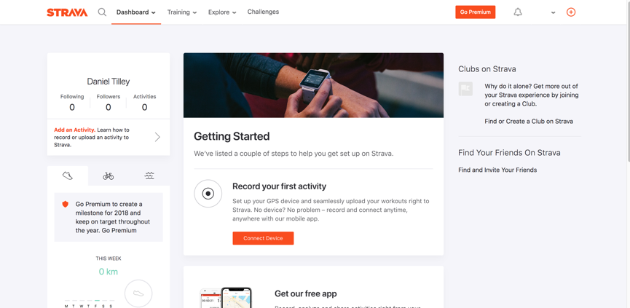

Figure 3: Strava Dashboard

### TrainingPeaks.com

In contrast with Strava, (Training Peaks, 2017) states that it “provides the complete web, mobile and desktop solution for enabling smart and effective endurance training”. They have a wide range of solutions available which allow them to accomplish this. The main one I will be focusing on is the web application. Unlike both Strava and Runtatic, Training peaks offers a good coach to client connection and does this quite well. Training peaks offers two separate editions of its web application. One for coaches and one for athletes. It means that athletes can utilise creation of training logs, events etc. and coaches are able to easily manage multiple athletes at one time. A coach could in theory update or create training logs for multiple athletes all within the same application with minimal copying of data to / from other systems.

Training peaks offers are very simplistic UI to its users. The colours used are quite bland and dull, yet the level of performance is quite high. It’s quite clear that a lot of work has gone into the functionality more so that the UI itself. Unlike the vibrant and pleasing colours of both Runtastic and Strava, Training Peaks adopts a solid grey background with some shades of blue thrown in here and there for good measure. Aesthetically, it is probably the worst out of the three for its lack of vibrancy and use of dull colours. As far as functionality and features go, training peaks is a fully paid for service that offers users a full week trial. The coaching edition is priced at either $19 or $49 per month along with a flat $99 fee for licences. The athlete’s version is priced at $19.95 per month or $119 annually. Features provided to the athlete include basic input / update functionality, find a training plan or find a coach. There are also graphs and statistics which are created based on data which has been input by the user. Coaches can build and share workout plans, analyse athlete data and create athlete profiles.

Although Training Peaks deals with the functionality side of things quite well, where its lacking is in its over simplistic and dull UI. Some of the text can be quite small and layouts are often squashed together. Another thing training peaks falls down on is its pricing. $119 annually for a service might not seem like a lot, but compared to the other two applications, it’s almost twice as expensive for similar functionality.

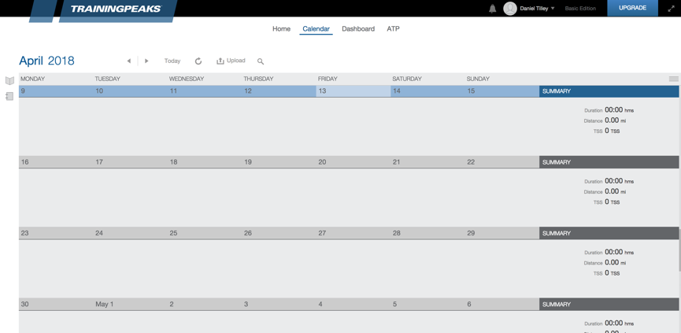

Figure 4: Training Peaks Dashboard

### Runtastic.com

Like Strava (Runtatic.com, 2017) “offers products and services that all focus on gathering and managing sports data to motivate people to do sports and to link like-minded people.” They embrace a similar community approach to sports like Strava. It is evident from a first glance at the Runtatic platform that it revolves heavily around this model. There are small features placed in the application which allow you to do things like cheer on users currently out exercising, join groups and add friends to motivate / get motivated from.

Runtatic offers great connectivity with both own brand or existing hardware and software. They offer basic create and update functionality for things like activities, training plans and personal info and a few other features here and there. Another plus is that they have support for entering data within several different sports unlike Strava. With regards to aesthetics, it’s a very simplistic, yet distracting application at times. There can be several things highlighted on a page at once and you may have to do a bit of searching to find your desired page, but the app itself is quite intuitive to use. Like the previous two sites, Runtatic also offers a premium service, however, like Strava, the premium functionality is limited and may not be needed by most users. They boast the ability to offer users enhanced statistics, nutritional input and guides as well as unlimited functionality for several of their free features. Pricing ranges from €49.99 per year to €6.63 per month.

Once again, what is missing from this application is that coach to client connect. This community-based application makes it difficult for coaches to keep track of their clients in an easy to use and efficient manner. Coaches may need to duplicate data or switch between applications / systems if they need to alter or create new training plans etc. for different clients.

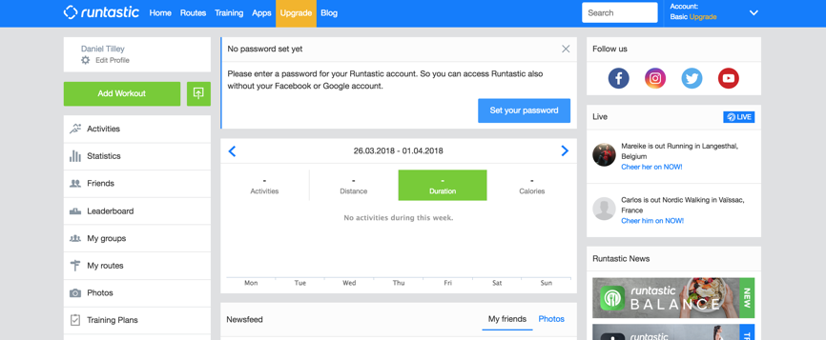

Figure 5: Runtastic Dashboard

## **Methodology and Approach**

### Continuous Integration

Continuous Integration (CI) enables automatic building and testing of code once any given member of a team has checked code into a repository. Once code has been committed, the CI system of choice will automatically pull from the given repository, build and or test the code itself. (Guckenheimer, S., 2017).

There are many advantages to using continuous integration no matter how big or small your team is. One of the biggest advantages is that it removes the need to manually run tests or builds on your local machine. This can be great for bigger teams since each member can see both the build and test results. For both large and small teams however, it is useful for freeing up system resources. It allows means that there is no need to devote a single developer to run tests, builds and deployments also. Continues integration really shows its worth however when it comes to longer builds or test runs. These can often be run over night and can often result in developers devoting their time to other more pressing issues.

CI does have some drawbacks however. Some CI systems can be very tricky and complex to setup and may require a lot of time to the initially setup. Another issue with CI is when the CI system throws unknown errors not related to a build or test runs. Severs may fail, network connections may die, disk space issues may arise, and this may lead to some frustration if tests or builds may need to be run again.

### Scrum Methodology

“Scrum is a subset of Agile”. It is quite a lightweight form of agile that is mainly based around processes or practices which must be closely adhered to. Scrum can be seen in environments which are related to either complex pieces of software or product development and which tend to follow iterative or incremental processes. (cPrime., 2017).

Scrum has many advantages associated with it. Because of this it is often one of the first methodologies chosen by a business to suit their needs. One of the main advantages of scrum is that it is a face paced and adaptive methodology. This means that problems or changes can be quickly overcome with little to no hassle. Scrum also ensures that sprints are kept short, lightweight and easy to maintain. Because of this, constant feedback is always provided, issues are identified well in advance and it is easier to maintain and deliver a quality project in a set period.

Scrum also has some key disadvantages however. It does not work well with single developer teams. Scrum usually dictates that there are several different roles on a Scrum based team. If a single developer was to take on these roles, they would be better off in the long run switching to a different methodology altogether. On top of this, if a task or tasks are not very well defined within a Scum based environment, it can often lead to a lack of clarity and can often lead to extra hours worked on a project there were never needed in the first place.

### Iterative Design

According to (Pidoco.com., 2017), “Iterative design is a process of designing a product in which the product is tested and evaluated repeatedly at different stages of design to eliminate [usability](https://pidoco.com/en/help/ux/usability) flaws before the product is designed and launched”. Iterative design can be utilised on any scale, big or small. Even if you are a solo developer, or work as part of a team, it can be quite a simplest, yet powerful methodology to follow.

By utilising the iterative design model, a step by step approach can be taken with the design and implementation of a piece of software. It allows for more thorough designs, implementations and can provide a better way of catching major defects before they manage to make their way into the system. As the system is contently built up over a phase of iterations, greater feedback can also be given on specific components of the system in question. As well as this, the iterative design model allows for more time spent on design and implementation and less time on documentation.

Some of the main drawbacks with iterative design however relate to how rigid each iteration can be. Because of this rigidity, there is often no overlap between phases. Another knock-on effect is to do with the overall system design. Since all requirements may not be gathered up front, design issues may arise due to uncertainty about the system.

### Pomodoro Technique

The Pomodoro technique is a time management-based approach used for organisation and completion of tasks. The idea behind the technique is to split your time into 25-minute blocks or sessions with a 5-minute break after each session. Once you have completed around 4 sessions, you are said to have completed a round of Pomodoro’s. (Focusboosterapp.com., 2017).

In theory, the Pomodoro technique is a fantastic way to optimise productivity. This is mainly due to the requirement of 25 minutes of highly focused work. It also enables the user to break larger tasks into smaller more manageable tasks. This may result in a better quality of work as well as less errors overall.

In practice however, the Pomodoro technique may not be best suited to a project of this variety. This is mainly because the final year project requires only a percentage of the student’s time and not all of it. Nonetheless, it would be best to try and implement the technique where possible to better manage the workload and keep the quality of work to a high standard.

### Kanban Board

Kanban boards are a way of visualizing tasks which relate to your current workflow. The board uses the concept of vertical lanes or columns on the board to separate tasks. Each lane can be given a unique heading such as ‘to do’ or ‘done’ and there is no limit on the number of lanes you can have on a single board. A Kanban card or is placed on the bored and will relate to a certain task within your workflow. (LeanKit., 2017).

Being able to visualise a work load can often put things into perspective. It’s very easy to plan something in your head and not truly realise the true extent or the sheer size of what’s involved. I liked the idea of the Kanban board because it meant that I would be able to keep track of things, prioritise and ensure that my workload would be kept at a reasonable level throughout the project.

Although the Kanban board has its benefits, it can be quite easy to overpopulate. There is also no set template for a Kanban board as each user’s requirements will differ.

### Gantt Chart

“A Gantt chart, commonly used in project management, is one of the most popular and useful ways of showing activities (tasks or events) displayed against time”. (Gantt.com., 2017).

Gantt charts can be quite a useful resource when it comes to project management. It enables both the person who created it and the person / people viewing it to easily keep track of what is happening within a given project. Because of this, it ensures that everyone is aware of important details such as timeframes, tasks and different requirements for each item on the chart. The Gantt chart also ensures that people can plan to prepare for items of greater complexity if required.

Some of the main disadvantages of Gantt charts lie with their complexity. As a Gantt chart can be a collection of many different items or tasks relating to many individuals or projects, its complexity can be quite overwhelming. This in turn can have knock on effects if, for example a deadline was extended. Because of this, the Gantt chart would have to be re drawn to facilitate new deadlines. Also, lines on a Gantt chart do not represent how much work may be involved in a certain set of tasks. It is merely an indicated of how long a given task may take to complete.

## **Technologies Requirements**

### Angular

Angular is a commonly used framework that allows developers to easily make applications for the web. Angular provides developers with functionality such as declarative templates, dependency injection and end to end tooling to allow developers to solve challenges they may be presented with. (Angular.io., 2017).

Angular was created and is currently maintained by google and has been around since 2010. It is becoming quite a widely-used framework now a day for several different reasons. It allows developers to create a single page MVC application that is driven and rendered completely through the browser. By doing this, you can limit the number of requests between both the client and the server, hence increasing things like loading and rendering time and decreasing wait times.

Angular also allows for separation and structure in your development. Features like templating and modular development allow for greater separation of code and can make things easier to identify. There is quite a steep learning curve with angular however, due to the fact it is written in typescript. However, the reward of sticking with the technology can be very fruitful in the long run. Angular can force developers to be much smarter in the way they work and develop code which can lead to less bugs and more time spent on productive coding.

### React

Unlike Angular, React is not a framework and is instead a library. Its focus is around UI and ease of implementation. In fact, (Reactjs.org., 2017) states that “React makes it painless to create interactive UIs”. React was created and is maintained by Facebook and has been around since 2013.

React itself has quite a fast learning curve associated with it since it is only a library and is based around JavaScript. React is becoming more popular and mainstream nowadays with many people choosing to adopt it over the likes of angular or vue.js due to its simplicity. However, one of Reacts biggest advantages can also be viewed as its biggest weakness. Its simplicity requires more input from the developers with regards to dependencies and another library’s.

Unlike Angular, React requires other third-party libraries to perform much of the functionality angular has out of the box.

### Bootstrap

“Bootstrap is an open source toolkit for developing with HTML, CSS, and JS.”

(Mark Otto, a,.2018). Bootstrap tackles two of the major inconveniences relating to web development, responsiveness and styling. It offers build in classes that can be used from within html to style items in a certain way. It makes building things like navbars, popups and modals so much simpler that it would be without Bootstrap.

As Bootstrap is so commonly used, one thing it’s not short on is support. There is rarely a question that has not already been answered on the likes of stack overflow relating to Bootstrap. It also provides fantastic documentation with many coded examples on the Bootstrap website.

The only real disadvantage to using Bootstrap is that it is a framework. Like all other frameworks, its subjected to versioning. When a newer version is released, breaking changes may be introduced.

### PHP

“PHP is a popular general-purpose scripting language that is especially suited to web development. It is also described as fast, flexible and pragmatic and is widely used in many different websites which currently exist” (Php.net., 2017) PHP first came into existence back in 1995 and has since been chosen by many as the language of choice for a server-side language.

PHP is often chosen due to the fact its free, simple to setup and maintain and that it can be embedded into HTML. It also fits into the LAMP stack and can be used in tandem along with other technologies such as a Linux distribution (most commonly Ubuntu), databases such as MySQL or even a web server like Apache. Whatever the reason for choosing it, PHP has quite a track record as a dependable and reliable server-side technology.

Along with the above, PHP also has fantastic documentation and is widely known across the world. If you ever have a problem which is PHP related, you can generally ask a member of the rather large PHP community, or consult the many pages of documentation associated with it. PHP also tends to be very scalable, so it can be used in any situation big or small.

One of the major drawbacks with PHP however is with regards to security. There are many flaws that exists with using PHP as a server-side scripting language. In some cases, hackers may be able to view PHP code if not secured properly and will be able to find weaknesses in the system.

### MySQL

“MySQL is the world's most popular open source database. With its proven performance, reliability and ease-of-use, MySQL has become the leading database choice for web-based applications, used by high profile web properties including Facebook, Twitter, YouTube, Yahoo and many more”. Mysql.com. (2017)

MySQL has developed quite a reputation in the world of web development. According to DevOps.com. (2017), “MySQL is globally renowned for being the most secure and reliable database management systems”. MySQL also offers great on-demand scalability options, a high level of performance and round the clock up time.

On the flip side of things, MySQL is known to have some stability issues. These issues tend to arise when it comes to references, transactions or audits. Along with these stability issues, MySQL has seen little to known development progress over the last few years. Because of this, flaws may be exposed and may take some time to patch.

### Mongo DB

MongoDB can be described as quite a modern and general approach to a database platform. It was designed to allow developers to utilise the full power of software and data to build very robust and advance applications. MongoDB. (2017)

MongoDB is one of the many different NoSQL databases which are currently available. Mongo uses both JSON and binary JSON (BSON) to store and access data. In contrast with standard RDBMS models, Mongo operates schema less and allows for more flexibility with regards to the data being stored. Another aspect of Mongo is that the application sending data to mongo will have to ensure that data is in the correct form / data type due to the much looser storage approach.

MongoDB like any other technology also has its disadvantages. Mongo can be very RAM intensive when performing operations due to its schema less approach. Applications may suffer long read and write times with large amount of data because of this. MongoDB also required that all data be manually updated in one way or another. This process can sometimes result in your entire database locking and requiring manual intervention to fix the problem.

### Apache HTTP

The Apache HTTP Server Project is a joint effort of many developers to create a powerful, open, industry standard server version of the HTTP protocol which allows its users access to many different features. Httpd.apache.org. (2017). The project itself has been around since 1995 and is responsible for running quite a considerable percentage of websites on the web to date.

There are many reasons why you would choose Apache http over any other web server. One of the main ones being compatibility. Apache is compatible with several operating systems ranging from windows to mac and even Linux distributions. It also offers developers the option to customise the server to greatly enhance their users experience. Apache is also free of charge and has great support / documentation. Also, seen as how apache has been around more than 20 years, the community around it is vastly experienced and available to help if needs be.

One of the major flaws with apache is that it is susceptible to security issues. By allowing access to its configuration, Apache often puts itself at risk of a lack of security if not configured properly.

### Nginx

“NGINX is the heart of the modern web, powering half of the world’s busiest sites and applications. The NGINX open source project started in 2002 and has grown exponentially over the past 10+ years”. NGINX. (2018).

There are many key reasons why an individual would choose to use Nginx. One of the key advantages which separates it from its competitors is its performance benchmarks. Nginx is extremely efficient and effective with its level of performance and can often handle 4 or 5 times more requests per second that its competitors. Nginx itself is also open source but does offer a plus version for enterprise. This means that there is quite a large support / development community behind it.

One of the drawbacks with regards to Nginx is its lack of modules / extensions when compared to the likes of apache. Some features users of the apache server may have become used to may not even be available as a Nginx alternative.

### Python

Python is a high level, object-oriented programming language which can be easily understood by developers. It offers a wide range of functionality such as data-structures and the ability to create dynamic variable types and binding. This often makes python the language of choice when it comes to both rapid application development and server-side scripting. (Python.org., 2017).

Python has been on the rise as one of the most popular languages since its conception in 1991. There are many reasons why someone may choose python as their preferred language of choice. Firstly, it is very beginner friendly and is also extremely easy to understand. Pythons lack of semi-colons and almost English like syntax means that any developer from beginner to advanced would be able to pick it up and understand it with ease. Secondly, Python has a great level of flexibility associated with it. There are no hard and fast rules about how certain features need to be designed or implemented. This offers developers more freedom to weave their own style into their approach. Finally, the Python community continues to grow and support one and other. With one of the largest communities on stack overflow, an answer to your question is never far away.

Python does have some draw backs however. When it comes to scalability, this is one area in which python does not excel. As a python app continues to grow, errors may become a lot harder to debug and ultimately fix.

### Java

“Java is a programming language and computing platform first released by Sun Microsystems in 1995. There are lots of applications and websites that will not work unless you have Java installed, and more are created every day. Java is fast, secure, and reliable. From laptops to datacentres, game consoles to scientific supercomputers, cell phones to the Internet, Java is everywhere!”. (Java.com, 2017).

There are a lot of reasons why a developer might choose to use Java as their language of choice for mobile development. Google who currently owns android have all their documentation written around the Java language and is their language of choice when it comes to native android development.

Android itself needs to run on many different devices and Java offers a way to compile and optimize native code on each of these devices. There are a lot of developers who are proficient in Java due to Java having open source support and lots of libraries to use. Java also protects against many exiting problems such as memory leaks and bad pointers. It can also be used to build sandbox style applications and implement a security model which prevents a bad app from ruining an OS. (Bayt.com., 2017).

Java however can also be quite slow. Often the process of compiling and running a java application can be much slower than other languages which are like it. Java also uses more system resources due to things like the JVM and garbage collector. These make it a lot more resource hungry than say C++ for example.

### Android

Android is responsible for providing functionality to millions of mobile devices all over the world. In fact, Android is the most installed of any mobile platform. This is due to its rapid usage growth which keeps on increasing day by day. Android enables developers to create and distribute mobile apps and games for Android through an open marketplace with ease on a world class platform. (Android, t., 2017).

Android itself offers developers a fantastic platform to develop native apps on. Having had a taste of mobile development for IOS using swift, I can safely say that android has its advantages over IOS in a development sense.

Android allows developers to distribute to any device running Android. It’s very simple, if you develop an app for android, it can be run on any device powered by it. With IOS however, you can only run your apps on an apple brand machine. Android is also a free platform to develop for and is easily accessible to anyway. No matter who you are or what OS you use, android is generally available to use. You can download android studios for windows, Linux and mac and can create a developer account free of charge. A fee of $25 is required however to push your apps to the app store. Apple on the other hand requires a mac to use XCode and swift and has a yearly recurring charge of $99 for their developer account. Along with the cost of the developer account, IOS apps can take some time to publish on the app store. Some may take anywhere from several days, to several weeks to be published whereas android will generally have your app up on the store within a few hours.

Android does have some drawbacks however. Often more code is required to create an android app than say an IOS app. This results in more time being spent on developing and android app compared to its competitors. Layouts and animations are much harder to implement on Android. Androids use of xml layouts may offer more customisation however, implementing complex layouts in xml can often be quite time consuming and frustrating.

### Angular-nvD3

Angular-nvD3 is “An AngularJS directive for NVD3 re-usable charting library (based on D3)”. (Krispo.github.io., 2017). It “allows users to easily customise charts via JSON API”. (Krispo.github.io., 2017).

This chart library allows developers to create complex charts in very simple ways. There is a good level of documentation associated with it and has quite an easy learning curve. As it is built on the ever popular D3 library, it already has a lot of functionality built in out of the box and a good level of support behind it.

As with any other framework or library however, what you see is what you get. Angular-nvD3 is no exception to this and if it doesn’t have what you are looking for, you may have to look elsewhere.

### Ng 2 Charts

Ng 2 Charts allows its users to develop “beautiful charts” (GitHub.com/Valor., 2018). Based off of Chart.js, its offers several basic graphs straight out of the box with little to no setup involved.

This chart library is a great addition to application. It is simple to use and install and is well documented above all else. Example are provided on the website and implementation takes no more than 30 seconds.

One of the big downfalls for Ng 2 Charts however is that active development has stopped and has been that way for little over a year now. Also, there is only a few graphs to choose from. This is all well and good if all you are looking for is a basic bar chart or pie chart, but if more complex graphs are what you are after, you may need to look elsewhere.

### SimpleWebRTC

According to (GitHub.com/AndyYet., 2018), SimpleWebRTC is described as the “world’s easiest WebRTC lib”. Its builds right on top of native web RTC api’s which are supported across most modern browsers. SimpleWebRTC enables users to build rich peer-to-peer apps in a matter of 5 minutes according to their site.

One of the main advantages of this library is that it comes pre-linked to a signalling and STUN server. This removes the hassle of having to devote resources to both within your own production environment. It also hides away most of the complex WebRTC api calls by offering a friendlier to use api.

Where this powerful little library falls down is in its support. A link to a single gitter page is the only means of an “FAQ” style page if you run into problems. You could find yourself scrolling for hours trying to find an answer to a “trivial” problem.

### Peer.js

“PeerJS provides a complete, configurable, and easy-to-use peer-to-peer API built on top of WebRTC, supporting both data channels and media streams”.

(GitHub.com/PeerJs., 2018). Like SimpleWebRTC, Peer.js acts as a wrapper to the native WebRTC api and offers a friendlier to use api.

Other than being easy to use and offering its own servers to use, it’s quite difficult to pick out any other major advantages offered by the library.

On the other hand, there are many reasons as to why a developer would choose not to use this library. For starters, the last active development on the project was more than 3 years ago. Functionality is also very limited.

### AWS

Amazon Web Services (AWS) is an example of a secure cloud-based platform which offers its users a multitude of different functionality such as compute power, database storage, content delivery and much more. AWS also enables businesses to grow and scale thanks to its cloud products and solutions which allow for flexibility, scalability and reliability. (Amazon Web Services, Inc., 2017).

AWS has been around for about fifteen years now and has been at the fore front of cloud hosting since it began to take off. It is one of the most preferred IaaS (Infrastructure as a Service) providers now a day also offering services such as its EC2 or Elastic Compute Service to anyone ranging from students to businesses. AWS has a lot of things going for it too. It boasts a very cost effective and scalable platform which offers a high level of security and flexibility. They also offer incentives such as a student access scheme for third level students which allows for greater availability.

Although AWS seems to quite a hot favourite when it comes to cloud hosting, it can also have its own drawbacks. The pricing model for AWS is very confusing at times and often leaves bemused as to what they are paying for. It can also become quite expensive as you scale up your operations to fit your needs. There is a steep learning curve associated with AWS also. Control panels are often difficult to navigate, and it can take some time to often find what you are looking for. It can often be overkill too. Although AWS offers quite a large amount of functionality, for something as simple as hosting a basic web page, it can be very much over the top. There have also been problems in the past where AWS is in accessible due to server outages.

### Digital Ocean

(DigitalOcean., 2017) describe themselves as “a cloud infrastructure provider focused on simplifying web infrastructure for software developers.”. When it comes to the area of web hosting, Digital Ocean are quite a strong contender. In fact, they are currently responsible for maintaining over “50000 teams” web sites including the likes of HP, Zen desk, Docker and many more.

They also state that their main advantages are “SSD-only-cloud, Simple Control Panel, Professional hosting starting at 5$, Active Developer Community and one-click installations”. What I really like about Digital Ocean is just how simple it is to use. If we come its control panel to the likes of AWS for example, its streets ahead. Digital Ocean also offer great transparency and clarity around pricing. You sign up, create your droplet and select how much you want to pay a month and it’s as easy as that. Another great thing about Digital Ocean is that they offer 50$ free credit through the GitHub education pack. This means that you can avail of a professional service without having to pay out any of your own money.

Some of the disadvantages of Digital Ocean are that they don’t offer and Windows based images, you are given the opportunity to make a mess of your server setup / maintenance and support isn’t the best.

### Recommender Systems

It is more than likely that anyone who browses the web on a day to day basis has encountered a recommender system in one form or another. A few popular examples would be the likes of Amazon, Facebook or Netflix. Recommender systems can provide recommendations to a user based on items or information analysed by the system. (Jannach, D., 2012). By using things like user preference and limitations or constraints, the system will try to recommend what it classifies as the most suitable items to the user. (Ricci, Rokach, and Shapira., 2010).

Recommender systems themselves are very popular and powerful additions to any system nowadays. They allow users to find items in a system which they may have never previously considered or may not have even known existed. They are also great for allowing the user experience to be personalised in a way that may not have been possible before their conception. They also work off real time data and decisions, so the user can always ensure that anything that is recommended to them will be of some relevance.

Recommender systems however do have their own drawbacks and down falls. They can often rely on vast amounts of data to exist in a database to make recommendations on. This can be a problem for newer systems that currently don’t have the same amount of data as well-established systems. On top of this, they can often at times return what users may consider ‘wrong recommendations’. This can be down to the popularity of an item that has been aimlessly interacted with, users inputting false data or once again, not enough data to analyse.

### Collaborative Filtering

An example of a recommender algorithm is Collaborative filtering. It uses data such as ratings, preferences and other user behaviour to make its predictions or recommendations to a user. The algorithm assumes that other user preferences can be combined to allow a prediction to be formed and provided back to the user. (Ekstrand, M., 2011). Collaborative filtering presumes that if a group of users tend to both like and dislike a set of the same two items, then that group of users will have a similar preference for a similar set of items. (Linden, G., Smith, B. and York, J., 2003).

Collaborative filtering is widely used across many different recommender systems in today’s day and age. There are several reasons why this is the case. Firstly, collaborative filtering is quite a versatile algorithm to use when it comes to recommender systems. Due to the simplicity of its implementation, it can be used across many different domains with ease. Collaborative filtering also doesn’t have a lot of overhead associated with it as opposed to the likes of content-based filtering. A very simple implementation would require a simple two-dimensional matrix with rows and columns specifying users and items for example. In the content-based model, there is often a lot of overhead associated with items that also needs to be stored to make recommendations to a user.

Although there are many advantages to collaborative filtering, there is also one major disadvantage. Collaborative filtering relies heavily on vast amounts of data already existing within a system. If there isn’t enough data within a database for the system to analyse, it cannot in turn make any recommendations, ultimately rendering the system useless.

### Content Based Filtering

Content based filtering is very like collaborative filtering. The main difference between the two is that content based filtering will mainly target a single user’s profile and a list of items as opposed to the multi user approach of the collaborative model. A single item and user will both have a set of attributes assigned to them. The user’s attributes will be updated as they interact with each item and this will ultimately update the users profile and enable the system to make future recommendations.

Nowadays user’s profiles are often generated by automated systems based on analysing their actions or choices, as opposed to a user manually inputting data about themselves. (Carreira, R., Crato, J., Gon?alves, D. and Jorge, J., 2004). Allowing the system to automatically generate the users profile data has its advantages. Common errors such as lack of user input can be avoided using this automated approach. The user does not have to worry about tracking items they have an interest in, this will be taken care of by the system. The user can also focus on simply using the application itself and won’t have to worry about an extra functionality.

A recommender system can use several different techniques such as relevance feedback, algorithms or Bayesian classifier to build up and learn about a user profile. (Recommender-Systems.org, 2012). All of which will allow the system to construct relevant recommendations for the for the user in question.

As with many techniques in machine learning, there are often weaknesses to it. Content based filtering and its weakness can often arise when a system solely relies on it. A study conducted on content-based filtering and the results showed that predictions could often be very in consistent based on the domain of the application. (Hurwitz, J., 2006).

### Artificial Neural Networks

“Artificial neural networks (ANN) are a form of computing for predicting a set of outputs from a set of input patterns (a set of variables). This machine learning method is motivated by the functioning of biological neural networks that consist of neurons and links (nerves). The neurons serve as the processing units and links serve as the connections between neurons.”. (Zhu, A., 2017).

There are a lot of reasons why a system might need to implement an artificial neural network. Neural networks have been applied in several different industries already to accommodate real world problems. They can solve very complex problems in a quicker amount of time than other algorithms or techniques may take. Neurons can be used in parallel to achieve faster computation times. They may also be able to apply human like reasoning to a given problem, find obscure patterns in data or even predict future trends with ease. (Ciobanu, D. and Maria, M., 2013). Whatever the case for choosing neutrals networks, they can be quite a powerful technique to use when it comes to data prediction or problem solving.

One of the major disadvantages with neural networks presents itself after a neural network has been trained. If we wish to add more data down the line to the neural network, we would either completely re-train it or start from scratch.

### K Nearest Neighbour

K Nearest Neighbour (KNN) is a lazy learning classification algorithm which is non-parametric. What this means is that the algorithm makes no underlying assumptions on the data and that there isn’t really any training phase associated with it. This results in quite a quick training phase, but because of this it is very inefficient in time and memory. (God, Your Book Is Great !!., 2017).

KNN is primarily used in situations where there is not a lot of knowledge about a dataset already. It works by firstly determining the distance of the closest K neighbours. It will then secondly classify its neighbours and will finally vote on each one of the nearest k neighbours to determine its own class. KNN is a very powerful algorithm due to its simplicity and because of its ability to produce non-linear decisions. It can really show its worth in recommender systems when analysing a whole dataset may not be an option.

One of the biggest downfalls of KNN however is when it comes choosing the value of K itself. There doesn’t seem to be defined way of choosing K. It is well known nonetheless that the lower the value of K, the less noise there will be from the given data, however a value of K that is too low may result in the model itself being too easily classified.

### Travis CI

“Travis CI is a hosted continuous integration platform that is free for all open source projects hosted on GitHub. With just a file called “.travis.yml” containing some information about our project, we can trigger automated builds with every change to our code base in the master branch, other branches or even a pull request”. (Basu, S., 2017).

Travis CI offers many advantages over its competitors. One of the biggest ones being that it is a hosted solution. Often with CI systems such as TeamCity, a local server is required to host and run the system itself. By offering hosting as part of the package, Travis makes it easier for smaller companies to really avail of continuous integration and all the benefits it has to offer.

One of the major disadvantages of Travis however is its lack of customisation. Developers will be forced to use third party add-ons for much of the functionality that is already provided by the likes of TeamCity.

### Selenium

Selenium is used to automate browsers and is primarily used for web application testing. (Seleniumhq.org., 2017). Selenium works by interacting with the DOM API via JavaScript driver. The driver can in turn be accessed using Java or C# bindings and can be used to run suites of tests for a given web application.

I have some previous experience with Selenium from my internship, so I am aware of what it can and can’t do, its advantages and disadvantages.

One of the major advantages of Selenium is that it is free and open source. How you choose to utilise it as a developer is completely up to you. Another advantage of Selenium is that it relies on JavaScript and DOM interaction. If a developer is familiar with either, it means that there will be a relatively low learning curve associated with Selenium.

On the opposite side of things, Selenium is often prone to unexpected crashes and strange errors. The community associated with Selenium is quite small. Because of this, questions you have may not yet have any answers. This can often result in a developer spending far too long trying to sort out issues when they could in turn be better spending their time elsewhere.

## **Findings**

After conducting a lot research on technologies, methodologies and techniques, I was able to produce the following findings:

### Researched Technologies

|  |  |  |
| --- | --- | --- |
| **Technology** | **Advantages** | **Disadvantages** |
| **Angular** | Has lots of built in functionality, does not require third party libraries to perform for common functionality and can be very rewarding to use. | Has a steep learning curve and is subject to versioning. |
| **React** | Easy to learn, simple to use and is very popular. | May require third party libraries to perform basic functionality. |
| **Bootstrap** | Easy to use, well documented and has great support. | Subject to versioning. |
| **PHP** | Free to use, easy to setup, works well as part of a LAMP stack, great documentation and community and is very scalable. | Security can be an issue if not done right. |
| **MySQL** | Very secure and reliable, highly scalable, offers a good level of performance and round the clock up time. | Has stability issues and development has ceased to exist on MySQL. |
| **MongoDB** | Flexible data storage and high data availability. | Very ram intensive. High amounts of data can cause deadlock on the database. |
| **Apache HTTP** | High level of compatibility with operating systems, customisable, free to use and offers great support and documentation. | Security issues relating to customisation. |
| **Nginx** | Open source and also very powerful and high on performance. | Doesn’t include many modules seen in the likes of apache. |
| **Python** | Easy to use and understand, very flexible and a great community and support associated with it. | Doesn’t tend to scale well. |
| **Java** | Offers solutions to optimise native code, open source support and prevents against things like memory leaks. | Can be very resource intensive / hungry. |
| **Android** | Can run on many devices, free to use and very good documentation. | Can often require more code to develop apps than other native solutions. |
| **Angular-nvD3** | Easy to use and well documented. | Functionality is limited. |
| **Ng 2 Graphs** | Easy to use and well documented. | Functionality is limited. |
| **SimpleWebRTC** | Offers a signalling and STUN server out of the box. Lots of examples. | Support is limited. |
| **Peer.js** | Easy to use, offers their own servers. | Possibly end of life. |
| **AWS** | Very cost effective and scalable, offers a high level of security and flexibility. | Can be quite confusing to use, offer more functionality than you may need, and pricing model can be ambiguous. |
| **Digital Ocean** | Simple to use, lots of customisation, very clear price plan and free credit through GitHub education pack. | No windows machines, customisation can result in destroying a virtual machine. |
| **Recommender Systems** | Very powerful and useful, can take away a lot of un needed data processing and can be tailored to a specific user. | May need a vast amount of data to function well and may provide in correct recommendations. |
| **Collaborative Filtering** | Very versatile, not a lot of overhead associated with it and easy to implement. | May require vast amount of data to function well. |
| **Content Based Filtering** | Can create customised user profile automatically and eliminates user input errors. | System can fall over when relying solely on Content Based Filtering. |
| **Artificial Neural Networks** | Can be used in several areas to solve many problems, can solve problems much quicker than standard algorithms and can also apply human like reasoning. | System must be re-trained if data changes. |
| **K Nearest Neighbour** | Extremely simple to use and implement. | Can have problems if not implemented correctly. |
| **Travis CI** | Hosted solution offered as part of GitHub education pack. | Lack of customisation. |
| **Selenium** | Open source and can be utilised in several ways. | Prone to unknown errors. |

### Chosen Technologies

|  |  |
| --- | --- |
| **Technology** | **Reason for choosing it** |
| **Angular** | Wanted to challenge myself (lack of experience) and good level of functionality offered. |
| **Ng 2 Graphs** | Easiest to use. |
| **Android** | Previous experience with it and it is free to use. |
| **Java** | Highly experienced in java and is android’s language of choice. |
| **Python** | Lots of libraries (including flask) and easy to use. |
| **Nginx** | Very easy to use and setup with high levels of performance and lots of support. |
| **MySQL** | Previous experience with it and it is free to use. Fits well in my chosen LAMP stack. |
| **Digital Ocean** | Very simple to use and credit offered as part of GitHub education pack. |
| **SimpleWebRTC** | Best WebRTC library available. |

### Other Findings

Finding regarding approach and methodology are discussed in the Design section of the document.

## **Requirements Table**

Below is a set of tables which outlines the set of requirements for both the mobile and web application. Each requirement is designated a phase, number or id, name, description and priority. The phase will relate to when the requirement was implemented in the development cycle. The priority implies how important it is to the overall project.

### Web Application

|  |  |  |  |  |
| --- | --- | --- | --- | --- |
| **Phase** | **Requirement Number** | **Name** | **Description** | **Priority** |
| 1 | 1 | User Login | Enable both athletes and coaches to login | HIGH |
| 1 | 2 | User Logout | Enable both athletes and coaches to logout | HIGH |
| 1 | 3 | User Sign Up | Enable both athletes and coaches to signup | HIGH |
| 1 | 4 | User Update Profile | Enable both athletes and coaches to update their profiles | HIGH |
| 3 | 5 | Athlete Create Training Log | Athlete can create a new entry on a given day of their training log | HIGH |
| 3 | 6 | Athlete Update Training Log | Athlete can update an entry on a given day of their training log | HIGH |
| 3 | 7 | Athlete Delete Training log | Athlete can delete a single training log if they wish to | HIGH |
| 3 | 8 | Athlete View Training Log | Athlete can view an entry on a given day of their training log | HIGH |
| 3 | 9 | Coach Create / Update / Delete Training Program Templates | Coaches can create / update / delete training templates that can be used when filling out training logs | HIGH |
| 5 | 10 | User search | Users can search for and other coaches / athletes and choose one to add to their list of coaches / athletes. | MEDIUM |
| 5 | 11 | Athlete Manage and Share Training Logs | Athletes can pick and choose what coaches to share their data with and what permissions they have | MEDIUM |
| 5 | 12 | Coach View List of Athletes | Coach can view all athletes which they are currently coaching. | MEDIUM |
| 5 | 13 | Coach Access Athlete Training Logs | Coaches can access athletes training logs given that they have permission to. | MEDIUM |
| 5 | 14 | Athlete set training targets | Athlete can set their given targets over a period. Can be seen by coaches and acted upon | MEDIUM |
| 6 | 15 | Coach Schedule One to One Consultations and Webinars and Participate in One To One | Coach can setup schedule one to ones or video conferences with athletes and can participate in one to ones also. | LOW |
| 6 | 16 | Athlete Create One to One Consolations and Participate in One to One and Webinars | Athlete can participate in one to ones and video conferences and can also create one to ones with coaches. | LOW |
| 7 | 17 | Athlete View Graphs | Athletes can view graphical data relating to their monthly training logs. | LOW |

### Mobile Application

|  |  |  |  |  |
| --- | --- | --- | --- | --- |
| **Phase** | **Requirement Number** | **Name** | **Description** | **Priority** |
| 2 | 1 | User Login | Enable both athletes and coaches to login | HIGH |
| 2 | 2 | User Logout | Enable both athletes and coaches to logout | HIGH |
| 2 | 3 | User Sign Up | Enable both athletes and coaches to sign up | HIGH |
| 2 | 4 | User Update Profile | Enable both athletes and coaches to update their profiles | HIGH |
| 4 | 5 | Athlete Create Training Log | Athlete can create a new entry on a given day of their training log | HIGH |
| 4 | 6 | Athlete Delete Training log | Athlete can delete a single training log if they wish to |  |
| 4 | 7 | Athlete Update Training Log | Athlete can update a new entry on a given day of their training log | HIGH |
| 4 | 8 | Athlete View Training Log | Athlete can view an entry on a given day of their training log | HIGH |

# **Design**

## **Chosen methodology and approach**

### Iterative Design

Iterative design was chosen over scrum as my methodology of choice. I felt as though it was better suited to a one-person team and was ultimately why I ended up choosing it. By using iterative design, I was able to break my requirements into different phases or iterations. Within each iteration, I was able to deal with the design, implementation and testing of each specific phase. By doing this I was able to easily monitor progress and stick to a schedule (outlined in section 6).



Figure 6: Iterative Design Process

### Kanban Board

A Kanban board was used to keep track of tasks for a given week / phase. By doing this enabled myself to visualise my workload at any given time. It was vitally important throughout the course of this project that I kept on top of all my requirements and tasks. By doing this I was able to ensure that deadlines were not missed and that my workload at a given time is evenly distributed. The Kanban board enabled me to do this and will ultimately played a very impotent role in the area task management.

The image below shows how I used Trello as my Kanban board for the project. Each component or section was given its own individual card. Each card would in turn be placed in a specific column on the board relating to what stage in the project it was at (TODO, Doing, or Completed). There is also a Testing column which laid out some of the unit test cases (discussed in section 5).

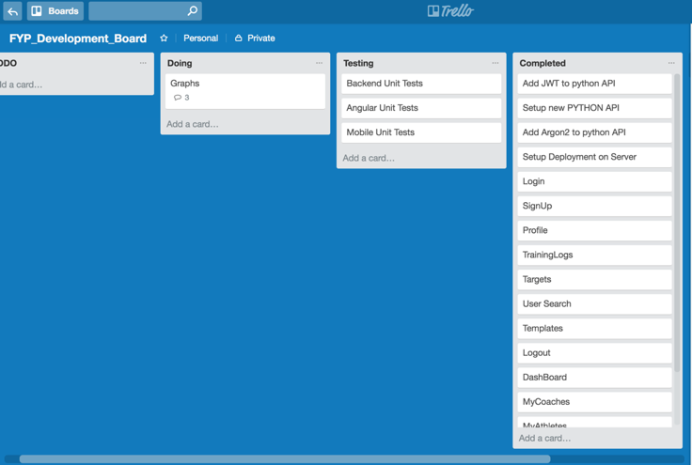

Figure 7: Kanban Board

Within the card itself, there would be several comments relating to the component in question. Anytime something had to be added to the component, a new comment was added and anytime it was completed, the comment was deleted. By adding comments and cards, it helped to visually indicate the number of tasks which I had to do per component and it also meant that the board was less cluttered with cards.

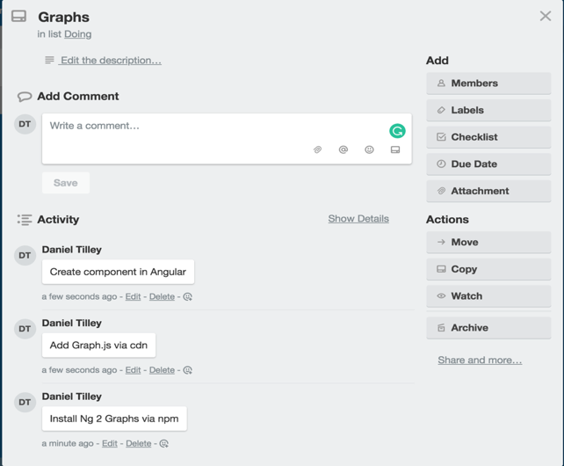

Figure 8: Kanban Board Component Comment

### Pomodoro Technique

To manage my time efficiently, I opted to use the Pomodoro technique where possible. Although it may not have been possible to devote full days to work on my project, I think it was important to ensure the quality of work produced was to a high standard. By utilising the Pomodoro technique where possible, I was able to ensure two things. Firstly, that any time devoted to working on my project will be well used. Secondly, that the quality of work produced in this time was of a good standard.

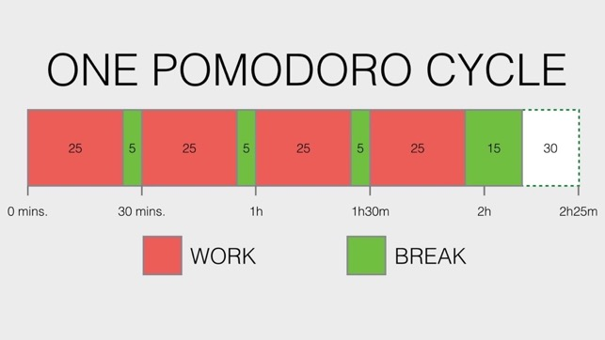

Figure 9: Pomodoro Technique

### Gantt Chart

A Gantt chart (included in section 6) was also be used to assist with time management and to ensure that the project stayed on track. It was used to plan remaining time and to make sure that other modules receive proper attention also. The chart included time off at Christmas, for exams and also incorporated time near the end of the project for documentation and testing. Although the Gantt chart is a good indicator of how long a certain phase may take, it may be by no means completely accurate. However, it was useful as a guide to stick to so that I could ensure all work was completed in a reasonable timeframe.

### Technical Architecture Diagrams

Both the Android and Angular apps will implement a Model View Controller (MVC) approach. The android app uses Java for functionality and xml for screen layouts. The angular app uses typescript for the functionality (this will be trans piled into JavaScript) and uses both html and css for screen layouts. The Python Flask Rest API is located on a single Ubuntu server alongside the MySQL database. Another Ubuntu server acts as a static file hosting server and serves HTML, JavaScript and CSS files (For the Angular App and also the static site) to a user. Both servers use Nginx in order to serve content and will be hosted on the digital ocean platform.

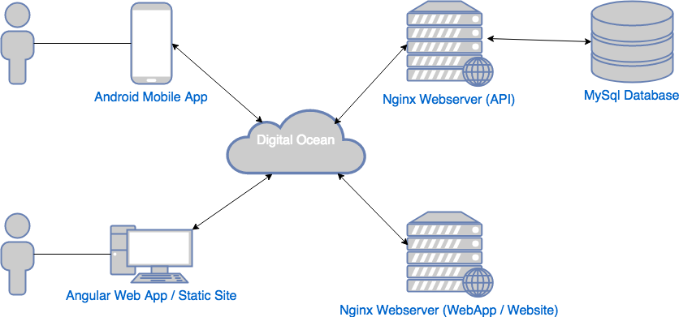

Figure 10: Technical Architecture Diagram (Network)

In order for the Python Flask app to communicate with the database, it will have to utilise PyMySQL driver / library.



Figure 11: Technical Architecture Diagram (Components)

### Entity-Relationship Diagrams

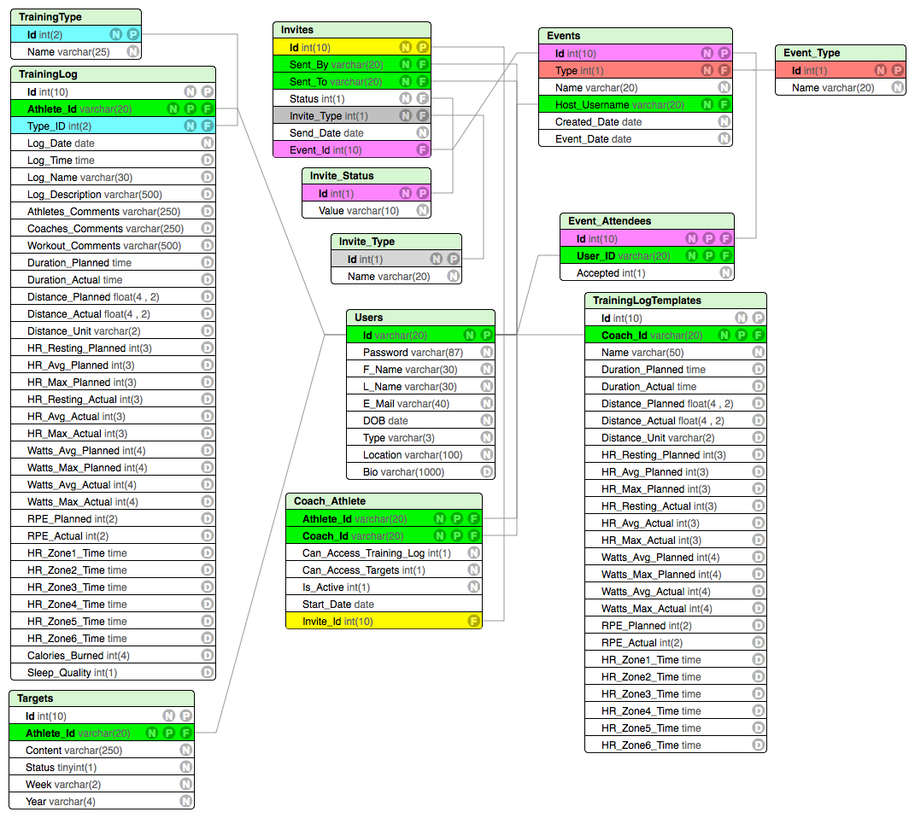

Figure 12: Entity Relationship Diagram

The above diagram is an entity relationship diagram for the Training Pal app. It shows a model of types of data that will be stored in the MySQL database. Primary and Foreign keys relating to the same column or datatype have been colour coded to make thigs easier.

## **Use Cases**

Within the application itself, there are pieces of functionality that can be accessed by both athletes and coaches, by only athletes and by only coaches. In the use case diagrams below I have outlined the major use cases which correspond to a type of user. The use cases were created for mainly the web application; however, all uses cases for the mobile application are contained within them also.

### User

Below are the use cases that will be shared by both types of user (coach and athlete).

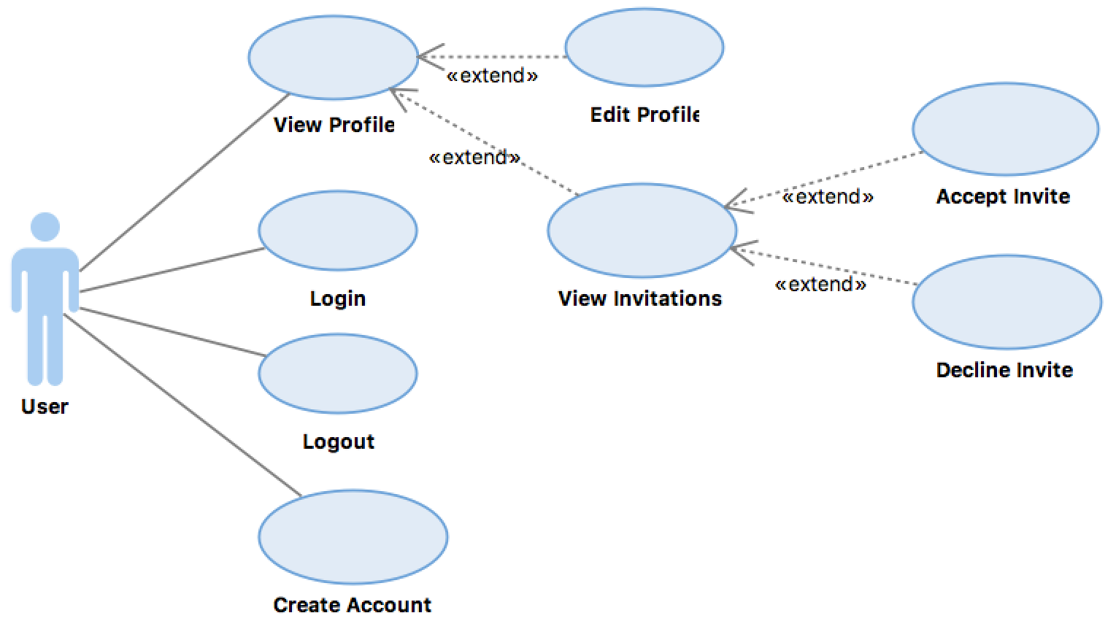

Figure 13: User Use Case Diagram

Both types of user will be able to avail of basic functionality such as logging in and out, creating an account as well as viewing their profile to either edit it or view a list of invitations. These uses cases (except invitations) will be accessible on either front end component (angular or android). The front-end component will make a request to the REST API, which will in turn retrieve data from the MySQL database return it to the calling component to fulfil the request.

### Coach

Below are the use cases that will be only accessible to the coach.

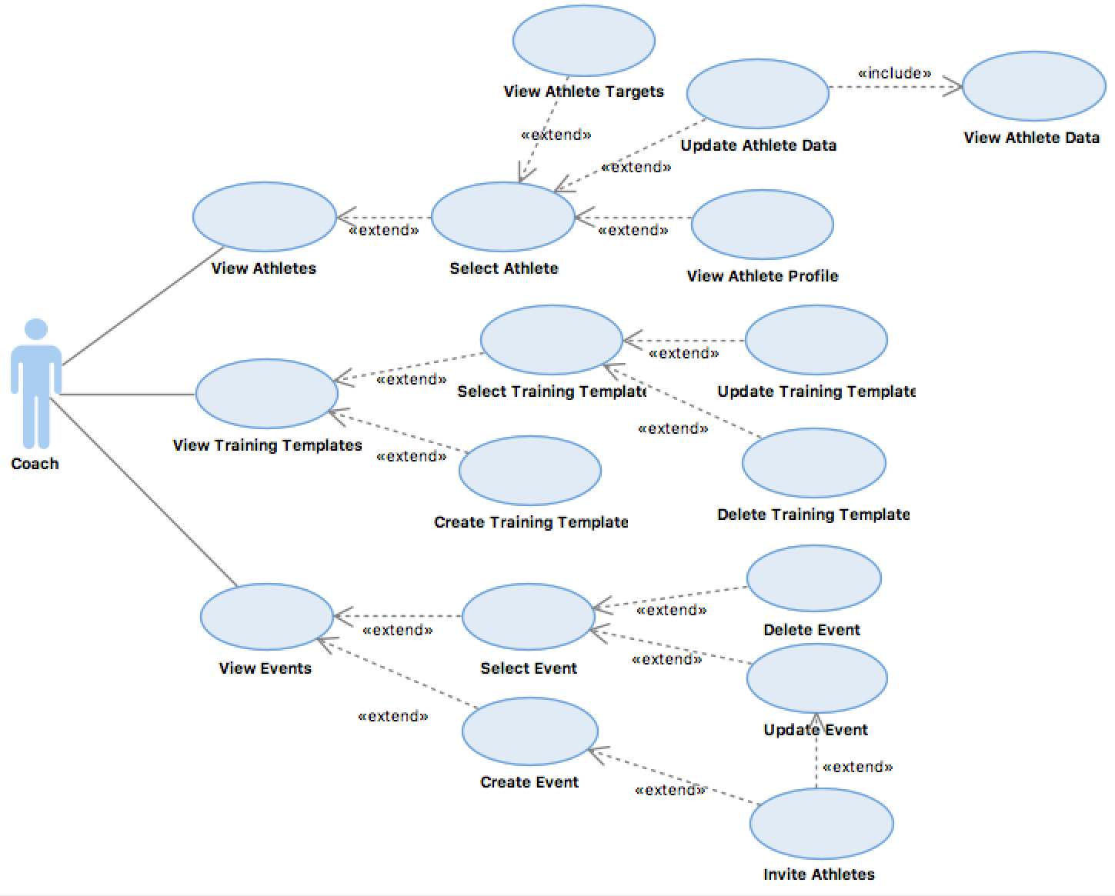

Figure 14: Coach Use Case Diagram

This use case diagram is divided into three sub categories. They are athletes, templates and events. The base use case for these categories is to view them. These base use cases will require the front-end component (only angular component for coaches) to make a request to the REST API, which will in turn retrieve data from the MySQL database and return it to the calling component to fulfil the request.

The angular front end will allow coaches to perform an array of tasks. One of the most important pieces of functionality for a coach will be the ability to interact with their athletes. They may do this in several different ways. If they wish to have no contact with their athlete, they may view an athletes training logs and update them accordingly for the coming week (If they have been granted access by the athlete). They may also view training targets set by athlete to better plan future sessions for them. If on the other hand a coach wishes to contact an athlete to discuss sessions, they may schedule a one to one consultation through the events page or they could view their profile to get their mobile number or e-mail address.

Another key piece of functionality for a coach may be to store training templates to use in the future. If a coach has specific session templates that they like to stick to or recommend to athletes, they can input them into the application and store them for later use. Alternatively, they will be able to use these templates when updating or creating training logs for their athletes

### Athlete

Below are the use cases that will be only accessible to the athletes.

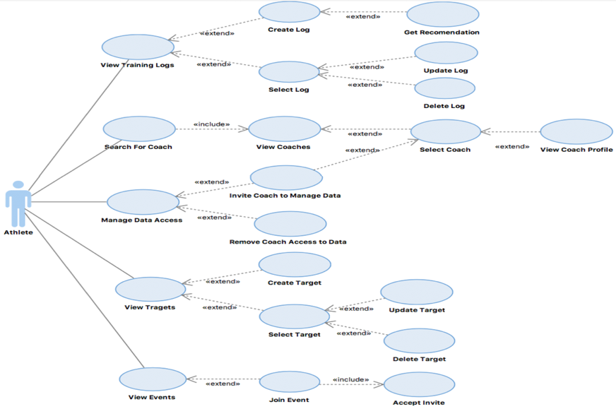

Figure 15: Athlete Use Case Diagram

This use case diagram is divided into five sub categories. They are training logs, coaches, data access, targets and events. The base use case for these categories is to view them. These base use cases will require the front-end component (only angular component for the coach, data access, targets and events categories) to make a request to the REST API, which will in turn retrieve data from the MySQL database and return it to the calling component to fulfil the request.

For the athlete, the most important piece of functionality will be storing their data. They will be able to achieve this from either the mobile app or the angular app. The will be able to perform basic functionality such as creating, updating and deleting of training logs and will also be able to view logs in a given period which will be defined by the user.

Another key piece of functionality the user may wish to avail of is training targets. An athlete will be able to indirectly communicate with a coach by creating and maintain training targets. They will show the coach what an athlete wants to achieve over several sessions and will be able to show the athlete whether they have achieved their original goals or not.

If an athlete does not already have a coach, they can search for one in the database and invite them to manage their data. Because of this, the coach will now be able to view targets and logs of the athlete in question. If an athlete no longer wants a coach to have access to their data, they may simply revoke their access.

Finally, if an athlete wishes to participate in events that they have been invited to by their coach, they may access this from an events page once they have accepted the invite. They will be able to participate in things like webinars or one to one consolations with their coach and fellow athletes.

## **Angular App Prototype**

Below is are some images of the prototype that was submitted for the interim submission. The prototypes were developed in angular and were fully functional. The aim behind the prototypes was to get myself familiar to angular and also to come up with a general idea of how to structure the project. Screen design was also considered at the time but was later changed. Below is an image of the login screen that was created for the prototype.

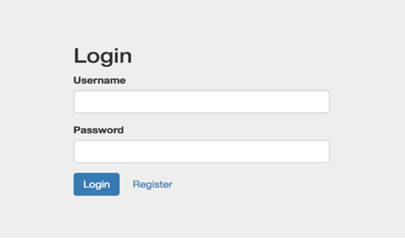

Figure 16: Angular Prototype Login Screen

The below image shows the profile screen where users could see information about themselves.

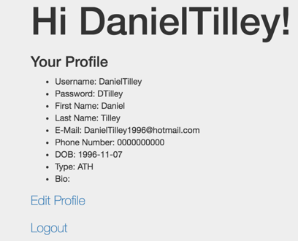

Figure 17: Angular Prototype Profile Screen

The below image shows the register and also the edit profile page. Users were able to create a profile and also edit their profile using this screen.

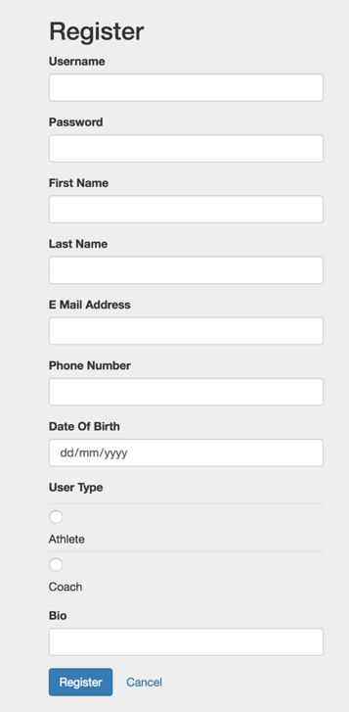

Figure 18: Angular Prototype Sign Up / Edit Profile Screen

## **Android App Prototype**

As opposed to the angular prototype, the android prototype was a lot more basic. A simple login screen was created that simply outputted a success or an error message when the user tried to login. Although an option to sign up was added in, the functionality behind it was not implemented at the time of submission. Like the angular app, screen layout was also considered at this time, but was changed at a later date to match the colour scheme of the web app.

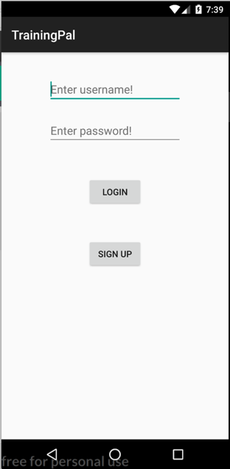

Figure 19: Android Prototype Login Page

# **Implementation & Development**

## **Overview**

This section deals with the implementation of the application and environment and also some of the issues that were faced.

## **Databases**

### MySQL

Both the Angular app and the Android app relied on a single MySQL database instance to persist data. A total of 12 tables (ERD located in Section 3) were used to across the database. I tried to keep the table count as low as possible in order to optimize the CRUD operations to and from the database.

Most tables cantered around the Users table, with the User_Id acting as a key identifier in several of the other tables. Passwords were stored fully encrypted in the database at rest. Argon 2 was the preferred method of encryption used due to its notable winning performance in the Password Hashing Competition back in 2015.

A Salt and Pepper approach was taken when encrypting the passwords before they were stored on the database. A fixed Pepper or key was stored as a system environment variable and then was appended to the user’s password and hashed with a random Salt or key.

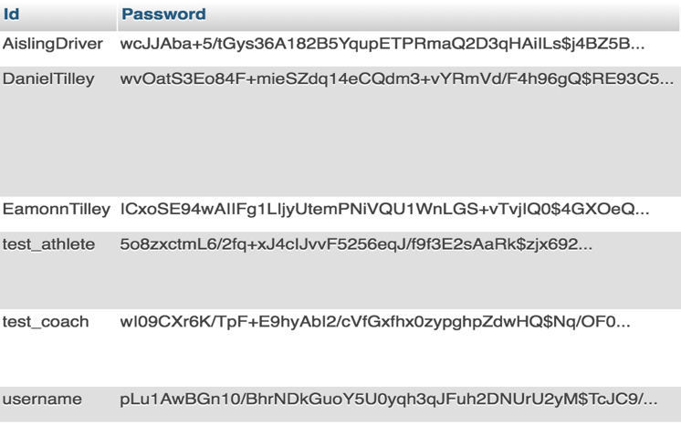

Figure 20: Passwords Encrypted at Rest

## **Servers**

I had originally intended to use a single Ubuntu virtual machine to host all components of my project. However, when it came to try to run both an api and a static web app through apache http, I ran into issues and instead opted on dividing the two. As a result of this, two Ubuntu virtual machines were used to host the various components of my project. Both VM’s resided at different IP Address’ on digital ocean servers and were accessible via SSH command with a previously generated RSA key.

A domain name was also obtained through the GitHub education pack from namecheap.com. On top of this, https was also implemented on both servers to ensure that all traffic to and from the server was fully secure.



Figure 21: Servers and Domain Name



Figure 22: Digital Ocean DNS Records

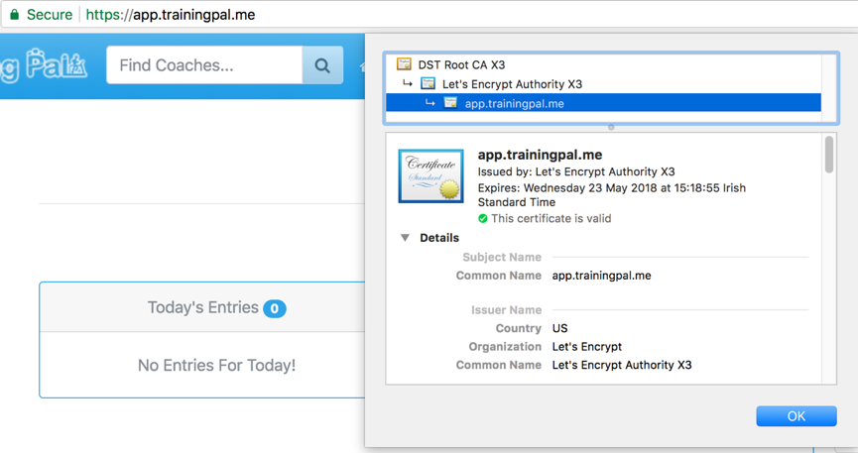

Figure 23: Https Certificate

### Python API and MySQL

An Ubuntu VM which runs Nginx is responsible for serving the flask driven python api. The api is executed using the uWSGI protocol and is accessible at the following url: api.trainingpal.me.

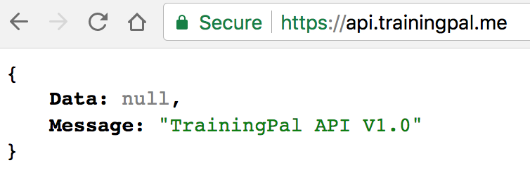

Figure 24: TrainingPal API Base Url

The MySQL instance runs on the same Ubuntu VM as the python api and is accessible at the following url: dbmanager.trainingpal.me/PHPMyAdmin. PHPMyAdmin is used as the default user interface to interact with the MySQL instance and was chosen due to its proven track record and also ease of use.

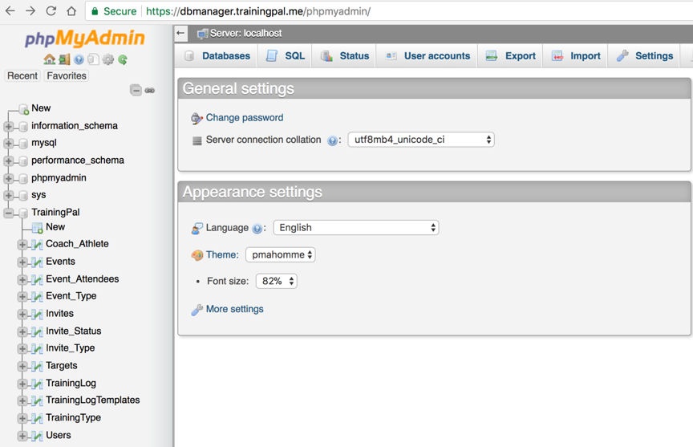

Figure 25: DbManager Url

### Angular App and Static Site

A second Ubuntu VM was run on a different server with the sole purpose of serving both the TrainingPal website (accessible at: www.trainingpal.me) and the TrainingPal web app (accessible at: app.trainingpal.me). Nginx was once again responsible for serving file to clients. It uses virtual blocks to determine which url has been accessed and then, return all files associated with that url.

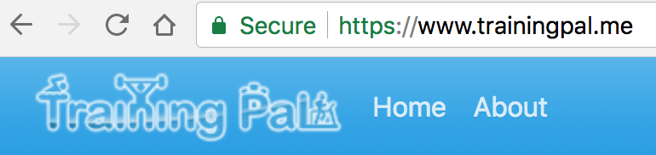

Figure 26: Training Pal Website Url

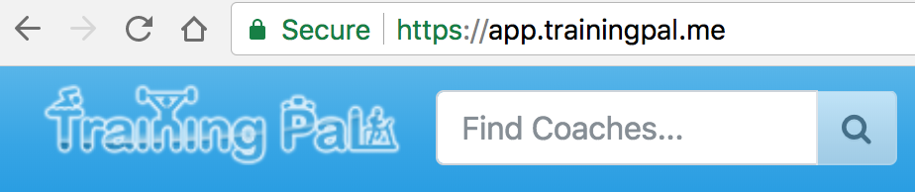

Figure 27: Training Pal Web App Url

## **Source Code Layout**

### Angular App

The below image outlines how the code is laid out within the angular app. Folders starting with “_” denote that classes are stored in these files. Folders that do not start with “_” denote that they are component folders.

The class folders hold files with deal more so with the logic of the application as opposed to the user interface. For example, there services folder contains a list of Dao style classes that are used to fetch and send data to the api. There are some special folders with angular specific classes such as the guards, directives, pipes and modules folder. Each of these folders hold classes that perform key functionality within the angular app. The modules folder for guard’s folder for example contains files responsible for checking if a user can access a certain url.

The component folders on the other hand are responsible for rendering the UI and handling specific page logic. In each component folder there is normally:

* A html template file (where page html is placed) – can be shared between 2 or more components.
* A type script class file (where page logic is implemented).
* A CSS file (for handling page specific styling).
* In some case there is also a spec file (where unit tests for that specific page are placed).

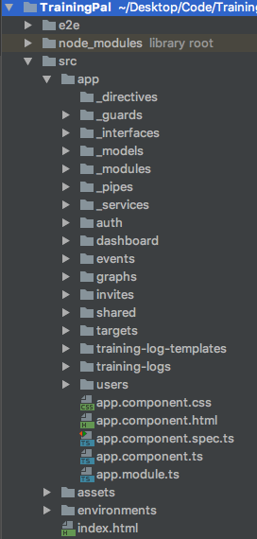

Figure 28: Angular App Code Layout

### Android Mobile App

The below image outlines how the code is laid out for the mobile app. Within the java folder there are several sub folders and files responsible for handling the logic of the application.

* Within the adapters folder are all that classes that are used to map data to a UI component e.g a list adapter.
* The fragments folder along with the activity files contains all the page specific logic.
* Call-back interfaces used for the networking side of things are contained in the interface folder.
* Networking specific service classes are contained in the services folder along with a local authentication service that stores and gets a web token for accessing the server.
* Contained with the shared folder are a list of files which contain UI logic for shared components such as forms, date pickers etc.

All of the layout / resource files relating to a page’s layout / structure can be found in the res folder.

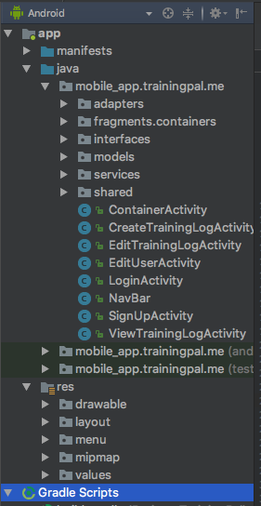

Figure 29: Mobile App Code Layout

Python Rest API

The python api is broken into several different folders with the entry point into the application located in the wsgi.py file located in the parent folder.

* The config folder contains information that is crucial to the configuration of the application such as the database credentials and the application secret key.
* As I opted not to use an ORM (regrettably), I had to create a constants folder which contained files with static strings that mapped to database tables. These are then references through the app when creating sql queries.
* The dao folder contains classes which are responsible for constructing and executing sql queries to get data from the database.
* Contained within the decorators folder / file is a single decorator function that is used to check for the present of a valid JWT token string with each request.
* The helpers folder contains a list of static classes that assist the dao and controller files in their functionality. One of the most used is the QueryBuilder.py file which is a static class that builds query strings for DAO objects.
* All models which map database tables to objects are stored in the models folder.
* The modules folder is the most important folder in the entire application. In contains all the controller logic for implementing end points that are accessible once the api is running. Modules are registered in the __init__.py folder located in the parent folder.

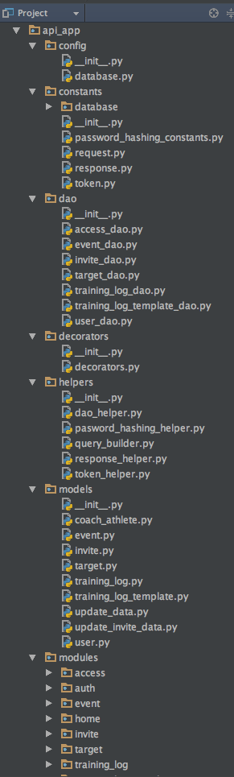

Figure 30: Rest API Code Layout

## **Python API**

The api uses both https and http v1.1 to transport information securely across the wire. The api accepts the following methods “GET, PUT, POST & DELETE”. It has several base endpoints exposed in order to retrieve data. These include:

* /auth
* /users
* /training-log
* /templates
* /targets
* /access
* /invites
* /events

Every endpoint (apart from /auth) requires that a JWT token string be sent to it in order for the calling user to authenticate themselves. If the token is missing an error response is sent to the calling user. The api returns a message in the following format along with standard response codes in the 2XX – 5XX range:

{

Data: SOME DATA,

Message: “SOME MESSAGE”

}

One of the biggest challenges faced when developing the api was figuring out how to structure such a large application. I spent quite a few days researching this and eventually came up with what we see here today. The design allows for great modularity and loose coupling of components within the api. It makes adding or removing modules very straight forward and easy to do.

Another issue I faced was when I was deploying the api to my original single server. I discuss the solution to this in more detail in section 6.

## **Angular App**

The Angular app sits on the web server as static js / html / css files that have be bundled and trans piled via the Angular cli. When a user sends a request to the web app url, the index html file is returned (entry point into the application) and then components are destroyed within the index file as needed. As it is a single page application, some configuration needed to be done with regards to 404 handling on the server (I discuss this more in the admin guide in the appendix) in order for it to run properly.

One of the biggest issues I faced with the Angular app was the fact that I had no experience whatsoever in developing a rich web client application of this scale. I spent a lot of time during my development phase referring back to a Udemy course I had taken and also looking for answers on forums such as stack overflow.

Another problem which occurred about 2 weeks before the end of the project involving a library I was using. The application was making requests to an external signalling and STUN api server which out of nowhere appeared to just go offline. I discuss the resolution to the problem later on in the document in section 6.

## **Android Application**

The android app acts as a standalone component within the 3-tier architecture and only requires access to the api to fetch / send data. The core functionality of the app was developed with little to no attention given to the UI / UX components. This was due to the fact that I was in the process of re designing my screen layouts and colour schemes and wanted to ensure that the functionality could be easily tied into the re-vamped UI.

Although for the most part there were no issues with the android development, I did run into a few problems here and there. Primarily there was an issue with the network library I was using to make calls to my api. As I had never used a networking library on Android before, setting it up and getting it to send and receive requests properly took some time. Eventually I got it working however and it was plain sailing from there.

Unfortunately, I had to take out one of the original requirements due to time constraints. I discuss how I decided what to remove and how I dealt with the problem in section 6.

# **System Validation**

## **Overview**

This section deals with the proposed and implemented testing methods that were used throughout the course of the project.

## **Requirements Testing**

“Requirements-based testing is a testing approach in which test cases, conditions and data are derived from requirements. It includes functional tests and non-functional attributes such as performance, reliability or usability”. (www.tutorialspoint.com., 2017).

Requirements testing is a great way to determine whether a piece of software is functioning properly or not. Anyone from a developer to even a business analyst could write very basic requirements tests to prove a system is working as intended. Nonetheless, there are a lot of things requirements testing cannot tell about a system.

To begin with, requirements testing in not concerned with how a piece of software functionally goes about implementing a requirement. Once the requirement is met, the test is considered passed. This can be quite a dangerous way to test a system if used on its own as there is potential for underlying bugs, flaws or weaknesses in the system they may go uncaught. Requirements may not also be written correctly. Because of this, the outcome of the test may through a false result while still functionally working as intended. Requirements also tend to change quite frequently within a system. Tests may have to be re-written for this reason and can have a knock on down the line.

Requirements testing was carried out as I worked my way through the development phases. At the end of each development phase, I would devote some time to sit down and run through the test cases (listed later in this section) and ensured they passed. If one failed, I would fix they application until it passed and would then re test any other components to ensure no breaking changes were introduced.

## **Unit Testing**

Unit testing allows developers to test the smallest components of a piece of software. A single unit test will focus on the “internal process logic and data structures within the boundaries of a component “. (Pressman, R., 2005).

Unit testing itself offers quite a lot of benefits. Problems with a single piece of code can often be uncovered quite quickly and early because of unit testing. Because of this, integration testing is often a lot quicker and easier. Unit testing can also enable developers to produce very accurate test coverage reports on their code. Finally, unit testing will also be able to verify whether the design of a piece of software is valid or whether there are problems with it.

On the flip side of things, unit testing also has some drawbacks. Unit testing itself can often be a very time-consuming process. On top of writing the unction code for the application itself, specific test cases will have to be created and implemented on top of this. Integration errors and system errors are very rarely caught also seen as how only the functionality of the code itself is tested. Finally, the accuracy of these tests may be sometimes called into question. Initial requirements for a specific test case may not have been setup correctly and could give a false result in the test.

Seen as how most of my testing resources were devoted to requirements testing, black box testing or system testing and also, seen as how my api or mobile app wasn’t being directly tested, I decided to write some unit test cases for them. Android unit tests were written in Java in android studios where as I conducted endpoint testing to evaluate my api.

The image below shows an example of a unit test written in post man.

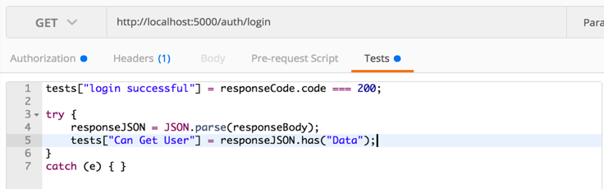

Figure 31: Postman Unit Test

The image below shows some of the android unit test cases that were executed.

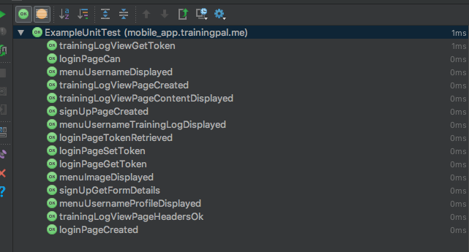

Figure 32: Android Unit Test Cases

## **Black Box Testing**

Black box testing is conducted without any understand of the code that drives the application. This is usually performed by someone with no knowledge of the internals of the system or who isn’t a programmer. Black box testing allows us to focus on the functional requirements and the results should relate to the intended goals in the documentation. Black box testing normally is comprised of many different tests, and as a result of this “test reduction is an important issue in black box testing”. (Patrick J. Schroeder, Bogdan Korel., 2000).

Black Box testing is a really good way to get a fresh take on your application. As the tester has no knowledge of the internal workings of the system, they may discover things that the developers may not have even noticed themselves. They may also be able to catch things missed in the likes of unit testing or some similar form of testing

I was fortunate enough to be in contact with a coach throughout the development process who was willing to test out each new version of the web application with one of his clients. They were able to give me valuable feedback in relation to bugs, feature changes etc., that helped me shape the project into its current form.

## **System Testing**

System testing is a way of determining whether a system meets both the functional and non-functional requirements. Usually the entire system is tested and system testing itself can be sub-divided into three sub categories. (Britton, C. and Doake, J., 2006). These three sub categories are Alpha, Beta and Acceptance testing and each have their own advantages and disadvantages.

Alpha testing is normally conducted by a test team or by the developer if there is no test team. Beta testing involves a group of individuals who volunteer to test the software having no prior exposure to it. Acceptance testing is performed by the users of the final production version of the software.

One of the main advantages of system testing is that you as a developer can receive feedback from a multitude of different users. It also allows the software to be tested by users who have had little to know exposure with them system itself. This can often result in errors arising that may have been previously missed by another individual. It also enables developers to receive realistic feedback about how the system performs overall and what they can do better.

The main disadvantage of system testing is that it can often be hard to source users to beta test. Alternatively, if your software isn’t very popular by some chance, feedback on the production version of your software may be limited.

During the course of the Easter break I organised for 1 coach and 6 athletes to use my application for about 15 minutes each and then give me some feedback in the form of a survey. None of the athletes or the coach had any prior experience with using TrainingPal and had all used one of its main competitors (TrainingPeaks) in the past. The survey they filled out is shown below along with some of the answers that were given.

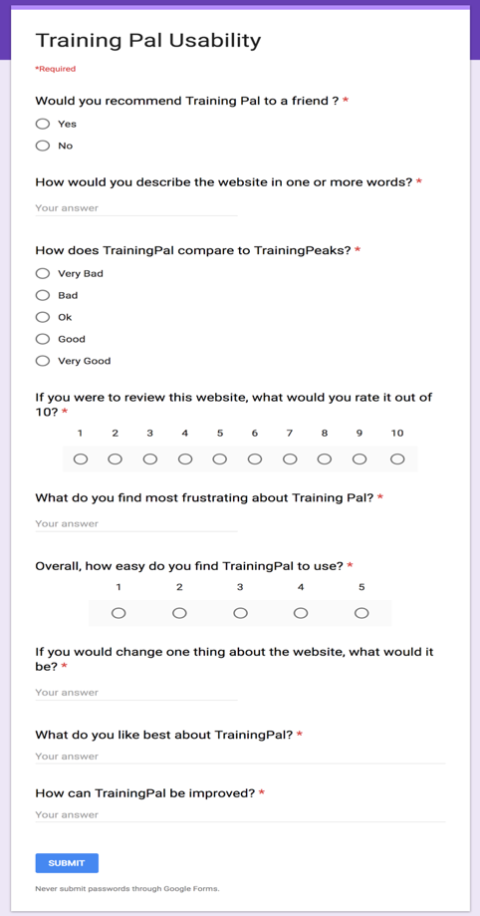

Figure 33: Usability Survey



Figure 34: Usability Survey Answer 1



Figure 35: Usability Survey Answer 2



Figure 36: Usability Survey Answer 3



Figure 37: Usability Survey Answer 4



Figure 38: Usability Survey Answer 5



Figure 39: Usability Survey Answer 6

## **Test Cases**

My most basic form of testing that I performed was requirements testing. Below are two tables which lists all the test cases for both the web and mobile app and their expected outcomes.

### Web Application

|  |  |  |  |
| --- | --- | --- | --- |
| **Phase – Test Case** | **Feature** | **Test Action** | **Expected Result** |
| 1-1 | Open Webpage | Open webpage by typing url in browser | Webpage opens, and login page is displayed |
| 1-2 | User Login with valid details | Enter valid login details | Home page is displayed |
| 1-3 | User login with invalid details | Enter invalid login details | Error is displayed |
| 1-4 | Register New User | Click register on login screen | New user is created and taken to the login screen |
| 1-5 | User logout | User clicks the logout button | User is logged out and re directed to the home screen |
| 1-6 | User View Profile | User Clicks on their name on home screen | User is taken to a view profile screen |
| 1-7 | User Edit Profile | User edits their profile after viewing it and clicks save | Users profile is updated and saved to the database |
| 3-1 | User View Homepage | User logs in or user clicks the homepage button | Correct user homepage is displayed (coach or athlete) |
| 3-2 | Athlete View Training Logs | Athlete navigates to home page | A list of training logs can be seen on the homepage for the current user |
| 3-3 | Athlete View Training log | Athlete navigates to homepage and clicks a single training log | All info relating to that log is displayed on screen |
| 3-4 | Athlete create training log | Athlete navigates to home page and clicks create training log, enters details and clicks save. | A new log entry is created and saved in the database. It should now be displayed on screen on the list. |
| 3-5 | Athlete update training log | Athlete navigates to home page and clicks a training log to view it. Athlete then clicks update button, updates log and clicks save. | Training log is updated, saved to the database and the updated log displays properly on the list. |
| 3-6 | Athlete delete training log | Athlete navigates to home page and clicks a training log to view it. Athlete then clicks delete button. | Training log is deleted from the database and the updated log is removed from the list. |
| 3-7 | Coach View Training Program Templates | Coach navigates to home page | A list of program templates can be seen on the homepage for the current user |
| 3-7 | Coach View Training Program Template | Coach navigates to homepage and clicks a single program template | All info relating to that template is displayed on screen |
| 3-8 | Coach Create Training Program Template | Coach navigates to home page and clicks create program template, enters details and clicks save. | A new template is created and saved in the database. It should now be displayed on screen on the list. |
| 3-9 | Coach Update Training Program Template | Coach navigates to home page and clicks a program template to view it. Athlete then clicks update button, updates log and clicks save. | Training log is updated, saved to the database and the updated log displays properly on the list. |
| 3-10 | Coach Delete Training Program Template | Coach navigates to home page and clicks a program template to view it. Athlete then clicks delete button. | Training log is deleted from the database and the updated log is removed from the list. |
| 5-1 | Athlete Search for Coach | Athlete navigates to find a coach screen and searches for a coach using one of filters | A list of coaches should be displayed on the screen |
| 5-2 | Athlete view coaches profile | After searching for a coach, the athlete clicks on the coach’s name | Coaches profile is displayed on screen |
| 5-3 | Athlete invite coach to view their data | After searching for a coach and clicking on their profile, the athlete can select what data to share and can click “invite to share” | Coach will receive an invitation and athlete will see the pending invite beside the coach’s name |
| 5-4 | Athlete manage data access | Athlete navigates to manage my data page, clicks on a coach, updates their privileges and clicks save | All privileges should be updated and correctly reflected on screen. |
| 5-5 | Coach View List of Athletes | Coach navigates to home page | A list of athletes whose data they currently manage will show up on the screen |
| 5-6 | Coach View Athlete Profile | Coach navigates to home page and clicks on “view profile” beside one of the athletes | Athletes profile will be displayed on screen |
| 5-7 | Coach View Athlete Data | Coach navigates to home page and clicks on “view logs” beside one of the athletes | List of athlete’s logs should appear on screen |
| 5-8 | Coach Edit Athlete Data | Coach first views athlete’s data, picks a log to alter and clicks the edit button beside the log name. | Coach should be able to edit the given log and changes should be saved to the database. |
| 5-9 | Coach View Athlete Targets | Coach navigates to home page and clicks on view targets beside one of the athletes | The athlete’s targets show now be displayed on screen |
| 5-10 | Athlete View Targets | Athlete navigates to my targets page | A list of athlete’s targets appears |
| 5-11 | Athlete Create Target | Athlete navigates to my targets page and selects create target, fills in information and clicks save | A new target will be created and saved to the database |
| 5-12 | Athlete Update  Targets | Athlete navigates to my targets page, clicks on a target, updates it and clicks save | Target should be updated and saved to the database |
| 5-13 | Athlete  Delete Targets | Athlete navigates to my targets page clicks on a target and clicks delete target | Target should now be deleted from the database |
| 6-1 | Coach Schedule One to One or Webinar | Coach navigate to events page and clicks new event. They choose the participant and fill in relevant information and click “schedule” | Event should be scheduled to take place and should be shown in a list. All athletes should have an invite sent to them. |
| 6-2 | Athlete participate in One to One or Webinars | Athlete navigates to inbox, clicks relevant invite and clicks accept. Once event has started, athlete navigates to events page and selects the event to participate in. | Invite should be able to be accepted or declined. Once invite is accepted, event should appear in events page. Athlete should be able to participate in event once started. |
| 7-1 | Athlete Can See Graphs | Athlete clicks on graphs screen. | This month graphical data should be displayed on screen to the user. |

### Mobile Application

|  |  |  |  |
| --- | --- | --- | --- |
| **Phase – Test Case** | **Feature** | **Test Action** | **Expected Result** |
| 2-1 | Open Application | Open application by selecting the icon | Application opens on login screen |
| 2-2 | User Login with valid details | Enter valid login details | Home page is displayed |
| 2-3 | User login with invalid details | Enter invalid login details | Error is displayed |
| 2-4 | Register New User | Click register on login screen | New user is created and taken to the login screen |
| 2-5 | User logout | User clicks the logout button | User is logged out and re directed to the home screen |
| 4-1 | Athlete View Training log | Athlete navigates to view logs page and taps a single training log | All info relating to that log is displayed on screen |
| 4-2 | Athlete create training log | Athlete navigates to view logs page and taps create training log, enters details and clicks save. | A new log entry is created and saved in the database. It should now be displayed on screen on the list. |
| 4-3 | Athlete update training log | Athlete navigates to view logs page taps a training log to view it. Athlete then taps update button, updates log and clicks save. | Training log is updated, saved to the database and the updated log displays properly on the list. |
| 4-4 | Athlete delete training log | Athlete navigates to view logs page and taps a training log to view it. Athlete then taps delete button. | Training log is deleted from the database and the updated log is removed from the list. |

# **Project Plan Evaluation**

## **Original Estimated Effort**

The two tables below outline the original time frame estimate given to each set of requirements within both the web and mobile applications.

### Web Application

|  |  |  |  |  |
| --- | --- | --- | --- | --- |
| **Version** | **Requirement Number** | **Name** | **Time Frame** | **Estimated Completion Date** |
| 1.0 | 1 | User Login | 1 day | 7/11/17 |
| 1.1 | 2 | User Logout | 1 day | 8/11/17 |
| 1.2 | 3 | User Sign Up | 1 day | 14/11/17 |
| 1.3 | 4 | User Update Profile | 1 day | 15/11/17 |
| 2.0 | 5 | Athlete Create Training Log | 3 days | 16/12/17 |
| 2.1 | 6 | Athlete Update Training Log | 1/2 day | 17/12/17 |
| 2.2 | 7 | Athlete Delete Training Log | 1/2 day | 17/12/17 |
| 2.3 | 8 | Athlete View Training Log | 3 days | 20/12/17 |
| 2.4 | 9 | Coach Create / Update / Delete Training Program Templates | 2 days | 23/12/17 |
| 3.0 | 10 | Athlete Find a Coach | 1 day | 16/1/18 |
| 3.1 | 11 | Athlete Manage and Share Training Logs | 3 days | 21/1/18 |
| 3.2 | 12 | Coach View List of Athletes | 2 days | 24/1/18 |
| 3.3 | 13 | Coach Update Athlete Training Logs | 4 days | 30/1/18 |
| 3.4 | 14 | Athlete set training targets | 3 days | 4/2/18 |
| 4.0 | 15 | Coach Schedule One to One Consultations and Webinars | 4 days | 11/2/18 |
| 4.1 | 16 | Athlete Participate in One to One Consolations and Webinars | 1 day | 13/2/18 |
| 5.0 | 17 | Athlete Recommendations by the System | 5 days | 27/2/18 |
|  |  | **Total Days:** | **36 days** |  |

### Mobile Application

|  |  |  |  |  |
| --- | --- | --- | --- | --- |
| **Version** | **Requirement Number** | **Name** | **Time Frame** | **Estimated Completion Date** |
| 1.0 | 1 | User Login | 1 day | 21/11/17 |
| 1.1 | 2 | User Logout | 1 day | 22/11/17 |
| 1.2 | 3 | User Sign Up | 1 day | 25/11/17 |
| 1.3 | 4 | User Update Profile | 1 day | 26/11/17 |
| 2.0 | 5 | Athlete Create Training Log | 2 days | 31/12/17 |
| 2.1 | 6 | Athlete Delete Training Log | 1 day | 3/1/18 |
| 2.2 | 7 | Athlete Update Training Log | 1 day | 3/1/18 |
| 2.3 | 8 | Athlete View Training Log | 2 days | 10/1/18 |
| 3.0 | 9 | Allow for Offline Usage | 2 days | 12/1/18 |
|  |  | **Total Days:** | **10 days** |  |

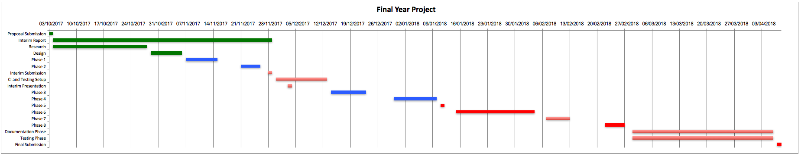

Figure 40: Gantt Chart

## **Changes Made to Requirements**

Within the original set of requirements, there was a specific requirement to add offline functionality the mobile application. After spending quite some time trying to come up with different ways to implement it, I made the ultimate decision to remove the requirement altogether. One of the main reasons for this was that I had allocated 2 days to work on the requirement, but I had spent those 2 days trying to figure out how to implement it. Seen as how I was already a few weeks behind schedule, I felt as though it would be best to leave the requirement for possible future work. Seen as how most people are connected to the internet majority of the time these days, I also felt as though it may be a bit of a niche requirement with specific use cases.

Near the end of the project, a library I was using (Peer.js) turned end of life and their servers went dead. The application had been using their signalling and STUN servers in order for the peer to peer web chats to work properly. As a result of this, I was forced to fix this which took several days away from my already tight schedule. I was also forced to drop the recommender system part of my requirements in order to facilitate the change and work with the time I had remaining. In its place however, I opted to added data visualisation functionality so that an athlete could see graphs of their training data for a given month.

## **PHP to Python**

A few weeks after I had submitted my interim reported I realised that PHP was not going to be a sustainable option as my language of choice for my API. Every time I needed to create a route, I was forced to create a new file containing the logic to handle that route. This in the long term would not have been sustainable as the number of files and routes within the project grew.

In order to combat the issue, I made a decision to switch to a Python library called Flask. I had already had very basic exposure to flask and seen as how I would be using python for the recommender system in my project, it just made sense to use flask and python. Unfortunately, this however did affect the overall timescale of the project. I had to learn how to use some flask features which I had not seen before, up skill my level of python coding and also re do work which I had already implemented in PHP. This added about 3 – 4 weeks on to the original time frame, but in the end, it was well worth it.

## **Servers**

As a result of switching to Python, I also ran into some issues with Apache HTTP. Apache does its job very well at serving static content, but when you need to host anything other than a HTML, JavaScript or CSS file, things tend to get “difficult”. I attempted to host my Flask app using uWSGI on Apache HTTP, but I spent many hours trying to troubleshoot a problem that seemed to have no obvious solution. Rather than trying to get it to work using Apache HTTP, I ended up using a new server with Nginx on it. I was able to use uWSGI with Nginx in order to host my Flask API with ease.

Whilst implementing Nginx on my API server, I realised how simple and easy to use it really was. I decided at that point to create a second Ubuntu server and to split the API and databases from the static web files. This meant that it was easier to manage things like logs and dependencies for each server and that tasks were spread across two different virtual machines as opposed to one (ultimately sharing the load).

## **Results and Evaluation**

Based on the results from the unit testing, requirements testing, black box testing and ultimately the system testing, I would have to put down the functionality side of things as a success. I was given some fantastic feedback throughout the testing process which really made it seem like a success overall. I ultimately achieved my main goals of creating a simple to use web application (confirmed by the feedback) and I also managed to incorporate a human to human element also.

Although the functionality side of things worked out ok, there is still an element of the project that I felt could have been better, the time management aspect of the project was extremely difficult at times due to countless setbacks and also heavy workloads in other modules. Nonetheless, I will take what I have learned from the project with me going forward and try to apply it where I can.

# **Conclusion**

## **Project Conclusion**

To conclude, overall, I would class the project as a success. I feel as though I have learned and taken so much from the experience not just in a computer science sense, but also in other aspects of life. I have learned a lot about my own abilities both technical and non-technical and have been able to improve in areas which I would have considered myself to be quite weak in previously. This project has helped me to become more confident in my own abilities, both technically and non-technically and I will always take what I have learned from the project with me in the future.

If I was to re do the project, I think I would be a bit more ambitious and have chosen to use a lot more unfamiliar technologies in order to possibly counteract any of the problems I faced over the course of the project. I would also have been a lot stricter with myself in relation to time spent on certain aspects of the project. I would have also liked maybe to add a small bit more complexity along the lines of machine learning into my project in order to give it that little bit extra.

## **Future Plans**

The coaches and athletes that evaluated my application gave me such positive feedback that I decided that I want to continue the development process of the summer and incorporate many more features that they suggested. Maybe one day my application could be the next big thing!

# **Bibliography**

Agarwal, B., Tayal, S. and Gupta, M. (2010). Software engineering & testing. Sudbury, Mass.: Jones and Bartlett, pp.171-173.

Amazon Web Services, Inc. (2017). What is AWS? - Amazon Web Services. [online] Available at:

https://aws.amazon.com/what-is-aws/ [Accessed 28 Oct. 2017].

Android, t. (2017). Android, the world's most popular mobile platform | Android Developers. [online] Developer.android.com. Available at: https://developer.android.com/about/index.html [Accessed 26 Oct. 2017].

Angular.io. (2017). Angular Docs. [online] Available at:

https://angular.io/docs [Accessed 18 Oct. 2017].

Basu, S. (2017). Travis-CI: What, Why, How. [online] Code Envato Tuts+. Available at:

https://code.tutsplus.com/tutorials/travis-ci-what-why-how--net-34771 [Accessed 28 Oct. 2017].

Bayt.com. (2017). Why do we use java for creating Android application? - Bayt.com Specialties. [online] Available at: https://www.bayt.com/en/specialties/q/4553/why-do-we-use-java-for-creating-android-application/ [Accessed 26 Oct. 2017].

Britton, C. and Doake, J. (2006). Software system development. London: McGraw-Hill, pp.171-173.

Carreira, R., Crato, J., Gon?alves, D. and Jorge, J. (2004). Evaluating adaptive user profiles for news classification. Proceedings of the 9th international conference on Intelligent user interface - IUI '04.

Ciobanu, D. and Maria, M. (2013). Advantages and Disadvantages of Using Neural Networks for Predictions. Ovidius University Annals, Economic Sciences Series, [online] 0(1), pp.444-449. Available at:

http://stec.univ-ovidius.ro/html/anale/ENG/cuprins%20rezumate/volum2013p1.pdf [Accessed 28 Oct. 2017].

cPrime. (2017). What is Agile? What is Scrum?. [online] Available at: https://www.cprime.com/resources/what-is-agile-what-is-scrum/ [Accessed 29 Oct. 2017].

DigitalOcean. (2017). Frequently Asked Questions. [online] Available at: https://www.digitalocean.com/help/ [Accessed 28 Oct. 2017].

DevOps.com. (2017). 8 Advantages of Using MySQL - DevOps.com. [online] Available at:

https://devops.com/8-advantages-using-mysql/ [Accessed 19 Oct. 2017].

Ekstrand, M. (2011). Collaborative Filtering Recommender Systems. Foundations and Trends® in Human–Computer Interaction, 4(2), pp.81-173.

Focusboosterapp.com. (2017). The Pomodoro Technique | What Is The Pomodoro Technique | focus booster. [online] Available at: https://www.focusboosterapp.com/the-pomodoro-technique [Accessed 29 Oct. 2017].

Gantt.com. (2017). What is a Gantt Chart? Gantt Chart Software, Information, and History. [online] Available at:

http://www.gantt.com/ [Accessed 29 Oct. 2017].

GitHub.com/AndyYet, (2018). andyet/SimpleWebRTC. [online] Available at: https://github.com/andyet/SimpleWebRTC. [Accessed 4 Apr. 2018].

GitHub.com/PeerJs (2018). peers/peerjs. [online] Available at: https://github.com/peers/peerjs [Accessed 4 Apr. 2018].

GitHub.com/Valor, (2018). valor-software/ng2-charts. [online] Available at: https://github.com/valor-software/ng2-charts. [Accessed 4 Apr. 2018].

God, Your Book Is Great !!. (2017). A Detailed Introduction to K-Nearest Neighbor (KNN) Algorithm. [online] Available at: https://saravananthirumuruganathan.wordpress.com/2010/05/17/a-detailed-introduction-to-k-nearest-neighbor-knn-algorithm/ [Accessed 28 Oct. 2017].

Guckenheimer, S. (2017). What is Continuous Integration? | DevOps. [online] Visual Studio. Available at:

https://www.visualstudio.com/learn/what-is-continuous-integration/ [Accessed 28 Oct. 2017].

Httpd.apache.org. (2017). About the Apache HTTP Server Project - The Apache HTTP Server Project. [online] Available at: https://httpd.apache.org/ABOUT_APACHE.html [Accessed 18 Oct. 2017].

Hurwitz, J. (2006). Empirical Evaluation of Content-Based Filtering for Personalization. [online] Hft.org. Available at: http://www.hft.org/HFT06/paper06/20_Hurwitz.pdf [Accessed 14 Nov. 2017].

Hwang, K. O., Ning, J., Trickey, A. W. and Sciamanna, C. N. (2013) ‘Website usage and weight loss in a free commercial online weight loss program: Retrospective cohort study’, 15(1).

Jannach, D. (2012). Recommender systems. Cambridge: Cambridge University Press.

Java.com. (2017). What is Java and why do I need it?. [online] Available at: https://www.java.com/en/download/faq/whatis_java.xml [Accessed 26 Oct. 2017].

Krispo.github.io. (2017). Angular-nvD3. [online] Available at: http://krispo.github.io/angular-nvd3/#/ [Accessed 26 Oct. 2017].

LeanKit. (2017). What is a Kanban Board? | LeanKit. [online] Available at: https://leankit.com/learn/kanban/kanban-board/ [Accessed 29 Oct. 2017].

Linden, G., Smith, B. and York, J. (2003). Amazon.com recommendations: item-to-item collaborative filtering. IEEE Internet Computing, 7(1), pp.76-80.

Mark Otto, a. (2018). Bootstrap. [online] Getbootstrap.com. Available at: https://getbootstrap.com/ [Accessed 4 Apr. 2018].

MongoDB. (2017). About Us. [online] Available at: https://www.mongodb.com/company?jmp=footer [Accessed 18 Oct. 2017].

Mysql.com. (2017). MySQL :: About MySQL. [online] Available at: https://www.mysql.com/about/ [Accessed 18 Oct. 2017].

NGINX. (2018). Company - NGINX. [online] Available at: https://www.nginx.com/company/ [Accessed 27 Feb. 2018].

Patrick J. Schroeder, Bogdan Korel (2000) “Black-box test reduction using input-output analysis”, pp. 173-177.

Php.net. (2017). PHP: Hypertext Preprocessor. [online] Available at: http://php.net/ [Accessed 18 Oct. 2017].

Pidoco.com. (2017). Pidoco - The Rapid Prototyping Tool. [online] Available at: https://pidoco.com/en/help/ux/iterative-design [Accessed 18 Oct. 2017].

Pressman, R. (2005). Software Engineering: A Practitioner's Approach. 6th ed. Palgrave Macmillan, pp.395.

Python.org. (2017). What is Python? Executive Summary. [online] Available at: https://www.python.org/doc/essays/blurb/ [Accessed 18 Oct. 2017].

Reactjs.org. (2017). React - A JavaScript library for building user interfaces. [online] Available at: https://reactjs.org/ [Accessed 18 Oct. 2017].

Recommender Systems. (2017). Content-based Filtering. [online] Available at: http://recommender-systems.org/content-based-filtering/ [Accessed 28 Oct. 2017].

Ricci, F., Rokach, L. and Shapira, B. (2017). Introduction to Recommender Systems Handbook. [online] Inf.unibz.it. Available at: http://www.inf.unibz.it/~ricci/papers/intro-rec-sys-handbook.pdf [Accessed 28 Oct. 2017].

Ride, J. R. (2013). A sports technology needs assessment for performance monitoring in swimming . Procedia Engineering, 442-447.

Runtastic.com. (2017). About Runtastic - Runtastic. [online] Available at: https://www.runtastic.com/en/about [Accessed 11 Oct. 2017].

Seleniumhq.org. (2017). Selenium - Web Browser Automation. [online] Available at: http://www.seleniumhq.org/ [Accessed 28 Oct. 2017].

Strava.com. (2017). Strava | About Us. [online] Available at: https://www.strava.com/about [Accessed 11 Oct. 2017].

TrainingPeaks. (2017). About TrainingPeaks. [online] Available at: http://www.trainingpeaks.com/about-us.html#about [Accessed 11 Oct. 2017].

Weinberg, R. (2003.). Foundations of Sport and Exercise Psychology. In Champaign (Ed.), Foundations of Sport and Exercise Psychology. Human Kinetics.

Wulf, G. M. (2002.). Enhancing the Learning of Sport Skills Through External-Focus Feedback. Journal of Motor Behavior, 171-182.

www.tutorialspoint.com. (2017). Requirement Based Testing. [online] Available at: https://www.tutorialspoint.com/software_testing_dictionary/requirements_based_testing.htm [Accessed 29 Oct. 2017].

Zhu, A. (2017). Artificial Neural Networks. International Encyclopedia of Geography: People, the Earth, Environment and Technology, pp.1-6.

# **Appendix**

## **User Guide**

### Training Pal Mobile App

Once the mobile app is launched, the user is brought to a sign in screen.

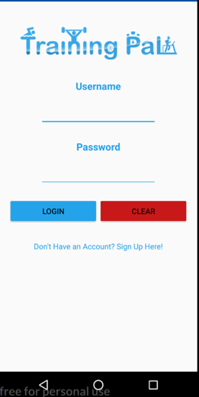

Figure 41: Mobile App Login Screen

If the user does not have an account, they can click sign up and will be brought to the sign-up screen. Upon signing up you will be returned to the login screen.

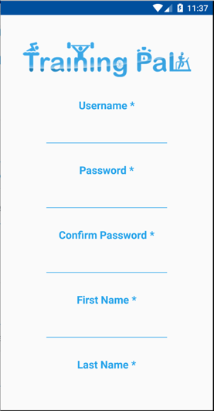

Figure 42: Mobile App Sign Up Screen

Once the user has been authenticated they will be directed to the training log screen. They can bring up the menu at any point by pressing the menu button in the top left corner.

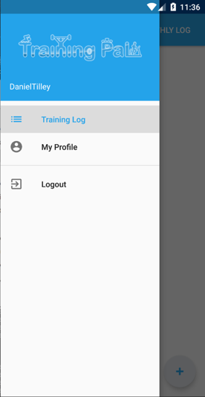

Figure 43: Mobile App Main Menu

The daily training log screen is the first screen a user is brought to when they are logged in. They can see a list of logs for today (if they have any) and can select one to view it in more detail.

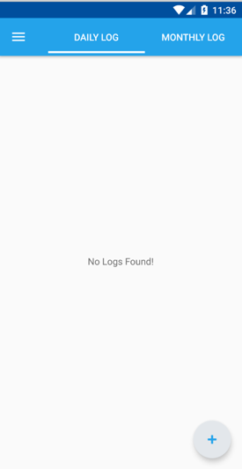

Figure 44: Mobile App Daily Logs Screen

If the user would prefer to look at their monthly logs however, they can click the monthly log button at the top of the screen to switch to that page and vice versa to go back to the daily log.

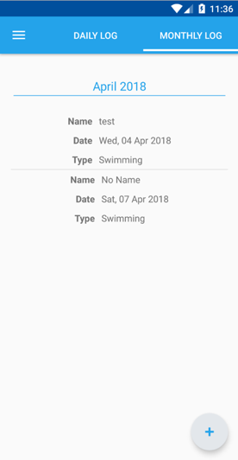

Figure 45: Mobile App Monthly Logs Screen

By tapping the blue plus in the bottom right hand corner, the user can navigate to the create log screen. Upon successful creation of an entry, they will be returned to the daily logs screen.

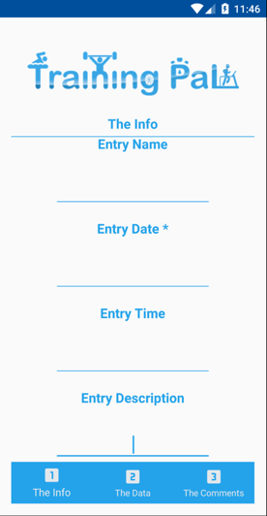

Figure 46: Mobile App Create Log Screen

By selecting the newly created item, the user will be brought to a view log entry screen where they have the option to update or delete the entry at the bottom of the page.

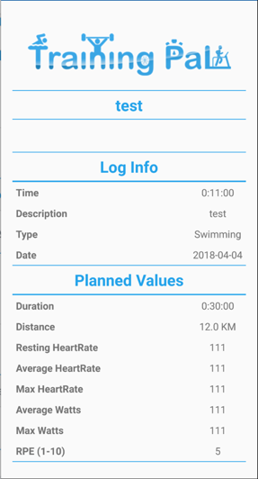

Figure 47: Mobile App View log Screen

If the user chooses to update the entry, they will be brought to the update screen where the form will be automatically populated with information relating to the log. The user can change any information they like and update the log by clicking update on page 3 (The comments.) Otherwise the user can press back to return to the previous screen.

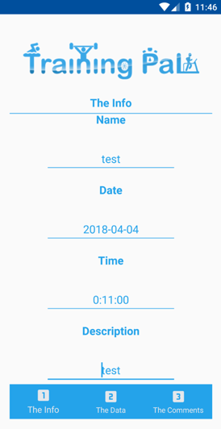

Figure 48: Mobile App Update Log Screen

Id a user clicks on My Profile from the main menu, they will be brought to My Profile page where they can view info about their profile. They can either press the back button to be brought back to the previous screen or can click on the Edit Profile button to edit their profile.

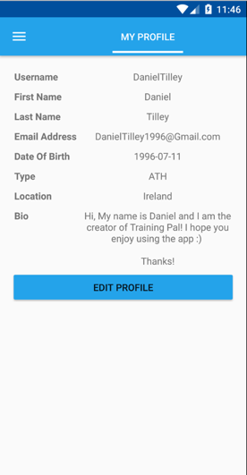

Figure 49: Mobile App View Profile Screen

Once the user is at the edit profile page, they can change details about themselves and update their profile. Once the form is submitted, they will be returned to the daily log page.

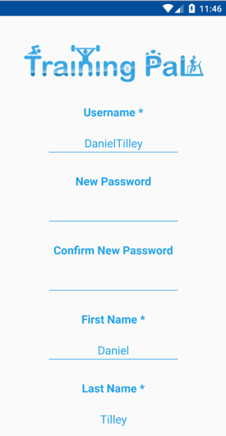

Figure 50: Mobile App Update User Screen

The user can logout at any time by opening the main menu and clicking logout.

### Training Pal Web App

When the web app is loaded if the user is not signed in, they will be brought to the login screen where the user must enter their password.



Figure 51: Web App Login Page

If the user does not have an account, they can go to the sign-up page and create and account. They will be redirected back to the login page once they sign up.



Figure 52: Web App Sign Up Page

Once the user has logged in the will see the main menu. If they are an athlete, it will look like this.



Figure 53: Web App Athlete Navbar

If they are a coach it will look like this.



Figure 54: Web App Coach Navbar

The dashboard will look like this for athletes and for coaches it will be missing the “Your entries section”.



Figure 55: Web App Dashboard Page

The user can type a username into the search bar and click the search button to find users with the opposite profile type to them. If they click on a user, they will be brought to their profile.



Figure 56: Web App User Search Page

A user can also see events they are attending or hosting by clicking their name in the top right corner on the nav bar and then selecting “my events”.



Figure 57: Web App Your Events Page

When clicking the “Create New Event” button, a new dialog will appear prompting the user to enter info about a new event.



Figure 58: Web App Create New Event Dialog

If the user instead choses to click on an event, they will be brought to the event page and can join the event in question.



Figure 59: Web App Event Page

The user can navigate to their profile by clicking on their name in the navbars and the selecting “My Profile”.



Figure 60: Web App Profile Page

If they click on edit profile, they will be brought to the edit profile page where they can change details about their own profile.



Figure 61: Web App Edit Profile Page

If a user wants to see a list of their received invites, they can click their name in the top right-hand corner and can then click “My Invites”.



Figure 62: My Invites Page

Only athletes will be able to see the training targets screen, unless they grant access to their coaches by searching for them, clicking on their profile and clicking “Grant Access”. Alternatively, a coach can request access by doing the same thing.



Figure 63: Targets Page

When the user clicked “Create New Target”, they will be prompted with a dialog that allows them to create a new training target.



Figure 64: Web App Create New Target Dialog

An athlete can see graphical data for the current month by clicking on the “Graphs” button in the navbar.



Figure 65: Web App Graph Page

An athlete can also see their list of coaches by clicking on their name and then clicking my coaches. They can manage their access by clicking on their name.



Figure 66: Web App My Coaches Page

An athlete can see their training log by clicking the “Training Log” button in the navbar. Coaches can access their athletes training logs by going to their list of athletes (same way as getting to my coaches) and then clicking on the training log button beside the athlete’s name.



Figure 67: Web App Training Log Calendar Page

The athlete can see their entries in either a calendar view or a list view, whatever is easier.



Figure 68: Web App Training Log List Page

The user can also create a new log entry by clicking on the create button.



Figure 69: Web App Training Log Create Page

The user can also view and entry by clicking on its name on either the calendar or the list. The option to delete and edit the event are present on this screen.



Figure 70: Web App Training Log View Page

Only a coach has the option to view and use training templates. Click the training templates button on the navbar to be brought to the list page. The user can click on any of the items to bring up the option to edit or delete them.



Figure 71: Web App Templates View Page



Figure 72: Web App Template View Page

## **Admin Guide**

### Servers

In order to connect to the servers, you must first obtain the RSA key or by granted access by someone who has to correct privileges to do so. Once you have obtained the key, you can simply connect via ssh to the VM on the server.

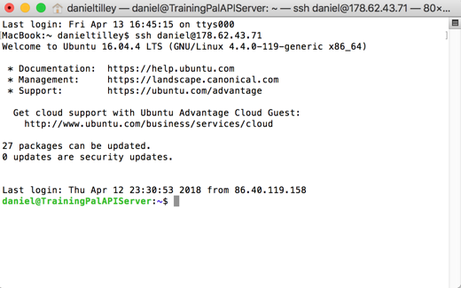

Figure 73: ssh connection

FileZilla was the preferred program of choice when deploying files to the server. You must obtain a valid RSA key to start with and then add it to FileZilla once you have it. Once that has been setup, you can use sftp protocol to connect to both servers to deploy the files.

For the api server, the folder in question is located at: /home/daniel/TrainingPalAPI. Simply copy and paste any new files over and replace existing files.

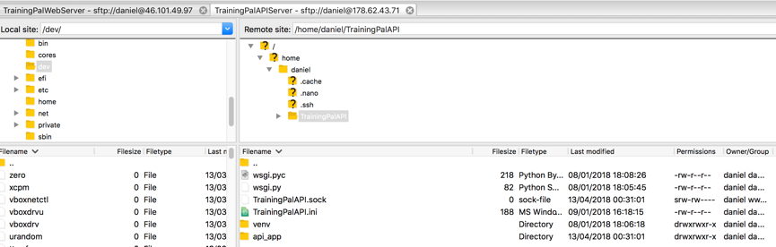

Figure 74: Filezilla API Connection

Once the files have been replaced, run the following command to restart the api service:

sudo systemctl restart TrainingPalAPI

For the webserver, the two folders in question are located at:

/var/www/app.trainingpal.me/html

/var/www/trainingpal.me/html

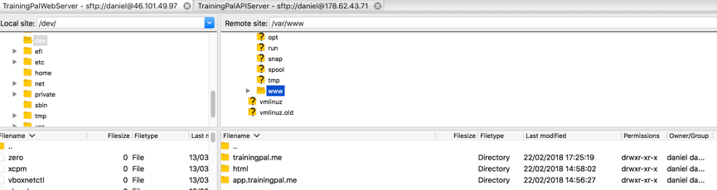

Figure 75: Filezilla Web Server Connection

Use the same process as outlined above for the api except for running the command.